**Thema 5** – 4 Som- en verschilgrafiek – Werkblad **Naam**:……………………… **Klas**:…………



**Opgave 1**

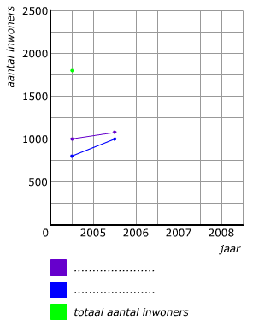

|  |  |  |  |  |
| --- | --- | --- | --- | --- |
| ***jaar*** | **2005** | **2006** | **2007** | **2008** |
| ***mannen*** | 1000 | 1100 | 1200 | 1300 |
| ***vrouwen*** | 800 | 1000 | 1000 | 1100 |
| ***totaal*** | 1800 |  |  |  |



**Opgave** **2**

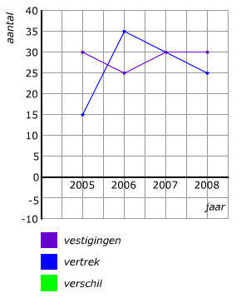



**Opgave 3**

|  |  |  |  |  |
| --- | --- | --- | --- | --- |
| ***Jaar*** | **2005** | **2006** | **2007** | **2008** |
| ***Dorp A*** | 1500 | 1500 | 1400 | 1350 |
| ***Dorp B*** | 1200 | 1300 | 1400 | 1500 |
| ***Som*** | 2700 |  |  |  |
| ***Verschil*** | 300 |  |  |  |



**Opgave 4**

