Opdracht:

Find the right picture with the right word.

FROG | GIRAFFE | DOG | CAT
RABBIT | HORSE | MONKEY | ELEPHANT
CHICKEN | COW | SNAKE | LION
HAMSTER | PIG | MOUSE | BIRD

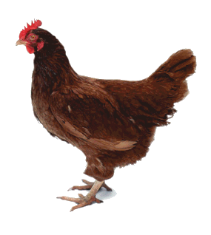 |  | 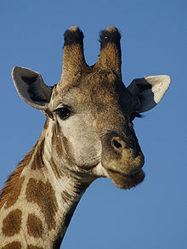 | 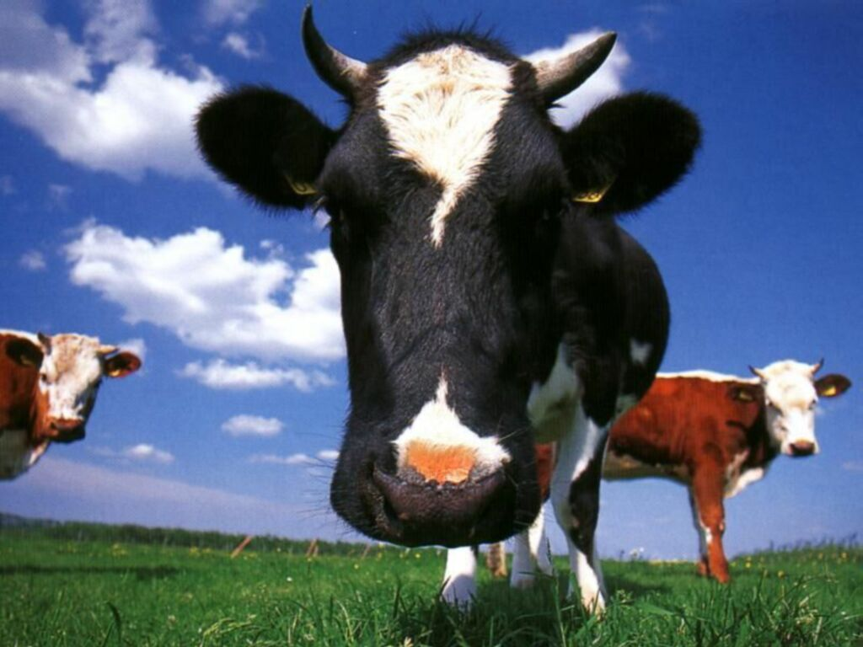
 |  | 