Tekstverklaring.

- Vul je naam (datum-klas) op het antwoordenblad in.
- Lees eerst de tekst goed door.
- Vul de antwoorden op het antwoordenblad in.

Opdracht 1: LEES DE TEKST.

A helpful friend

Have you ever seen a grizzly bear? It normally lives in the forests of North America, but you may have seen one at the Zoo.
The farmers of North America shot the bears because they wanted their furs⁽¹⁾ and also because they were afraid that the bears would kill them and their animals.
One story tells us of a bear that killed more than 1200 cows in two years.
There are, however, stories of grizzlies that made friends with farmers. The story of Bill Jones is an example.

One day, Bill Jones was looking after his cattle. Suddenly, a large grizzly attacked him and he had to shoot it. Then he saw the grizzly’s baby. He didn’t want to kill it, so he took it home as a pet ⁽²⁾. The bear grew up and followed Bill everywhere.
A few months later, another bear attacked Jones. He fell to the ground. He looked in the bear’s eyes and thought, “it is going to kill me!”.
Suddenly the bear stopped and turned around. There was another grizzly bear behind it- Jones’pet grizzly which had come to his help. Quickly Jones got up and ran away. His pet had saved his life.

- fur = pels, bont, vacht
- pet = huisdier

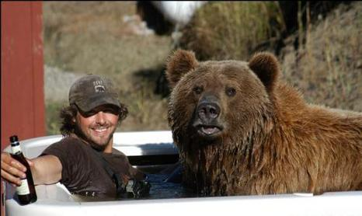

Opdracht 2.

Tekstvragen.

- Where do grizzly bears normally live?
- They only live in Zoos
- They live in North America.
- They only live on farms.
- They live in homes as pets.
- They live near cows.

- You have probably seen grizzly bears….
- in the forest
- on a farm.
- At school.
- At the Zoo.
- On Bill Jones’ farm.

3. Why did the farmers shoot the grizzlies?
- they were dangerous
- They were helpful.
- They were pets.
- They wanted their babies.
- They stopped and turned around.

- How do you know that some grizzlies made friends with farmers?
- From pictures.
- From one of the farmer’s friends.
- From stories.
- From TV-reports.
- From pets.

- What was Bill doing when he was attacked for the first time?
- Shooting bears.
- Telling stories.
- Fetching the grizzly baby.
- Looking for his friend.
- Looking after his cattle.

- What kind of bear attacked Bill?
- A polar bear.
- A large grizzly.
- A small brown bear.
- A large pet.
- A baby bear.

- What did Bill do with the baby grizzly?
- He took it home.
- He took it to a friend.
- He shot it.
- He followed it all the time.
- He took it to his neighbour.

- When Jones was attacked by a second bear he……
- took it home for a pet.
- Shouted for help.
- Thought it was going to kill him.
- Shot it dead.
- Wanted its fur.

- Why did the attacking grizzly turn around?
- Jones’s pet grizzly had come to help him.
- Jones fell to the ground.
- Jones was dead.
- Jones shouted so loud.
- Jones had hit it on the ground.

- Who was the helpful friend in this story?
- One of Bill’s children.
- Bill’s neighbour.
- A North American farmer.
- Bill’s grizzly pet.
- The attacking grizzly.

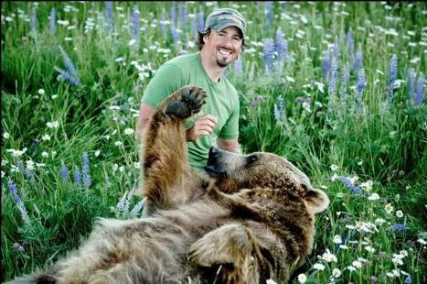

Opdracht 3

- A large group of trees is called a……
- forest.
- Reservation.
- Town.
- Village.
- Farm.

- A farmer (line4) is a man who…….
- who buys and sells bears.
- Sells farms.
- Builds houses.
- Shoots animals.
- Grows potatoes, corn etc.

- They were afraid (line6) means that……….
- they were surprised.
- They were happy.
- They expected something good.
- They were frightened.
- They were in a hurry.

- The “cattle” (line 12) on a farm are…….
- chickens and hens.
- Cows and bulls.
- Horses and donkeys.
- Dogs and cats.
- Sheep and rabbits.

- “to make”in “grizzlies made friends” (line 10) means……….
- to have.
- To do.
- To become.
- To try.
- To be.

- “the bear followed Jones everywhere” (line16) means…………..
- Jones never knew where it was.
- It was sometimes with him.
- It never went with Jones.
- It always went with Jones.
- Jones always followed it.

- “A few months later” (line 17)………………….
- the same month.
- Some months later.
- Many, many months later.
- A short time before.
- 30 days after.

- “another bear” (line 17) means……………..
- a dangerous bear.
- A different bear.
- An attacking bear.
- A grown-up bear.
- The same bear.

- In welk van de volgende gevallen wordt “ea”op dezelfde manier uitgesproken als “bear”.
- waer.
- Sea.
- Team.
- Speak.
- Tea.

- In welk van de volgende gevallen wordt “ou” op dezelfde manier uitgesproken als “thought”.
- loud.
- Through.
- Bought.
- Foul.
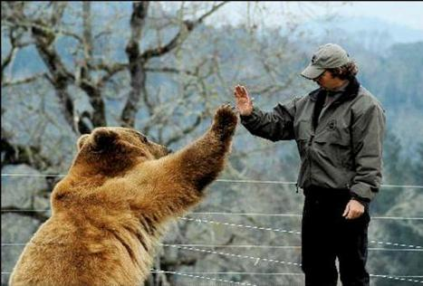
- Colour.

Opdracht 4

- Bill says, “Mary, I am going to look after the cattle.” This tells us that Bill…..
- had already looked after the cattle.
- Wants Mary to look after the cattle.
- Had never looked after the cattle.
- Doesn’t want to look after the cattle.
- Has decided to look after the cattle.

- Bill says, “The grizzly eats a lot of sugar”. This means that the grizzly…………
- will do it tomorrow.
- Did it yesterday.
- Does it sometimes.
- Never does it.
- Normally does it.

- Bill says, “our grizzly has stolen the sugar”. This tells us that………..
- the grizzly does it everyday.
- the grizzly is doing it now.
- There’s no sugar left.
- Bill never had any sugar.
- the grizzly will do it the next day.

- Bill says, “it is going to kill me”. This means that……………
- Bill was already dead.
- Bill thought he would die.
- Bill was to die some months later.
- Bill was never going to die.
- Bill has been killed.

- Bill says, “our pet is sleeping in the hut”. This tells us that……………
- it is sleeping there at the moment.
- It never sleeps there.
- It will sleep there.
- It has just slept there.
- It always sleeps there.

- John is talking to Bill. Bill’s answer is: No, I’ve never been to a Zoo.
What was John’s question?
- What’s a Zoo?
- Did you talk about Zoos at school?
- Will you go to the Zoo tomorrow?
- Have you ever been to a Zoo?
- Why do you like Zoos?

- “The farmers of North America shot the bears”(lines 4/5) means that……………
- they will shoot them.
- they shot them some time ago.
- They will shoot them.
- They never shoot them.
- They are shooting them at the moment.

8. “Bill Jones…………the grizzly yesterday”. Welke werkwoordsvorm vul je hier in?
- doesn’t shoot.
- Will shoot.
- Shot.
- Has shot.
- Shoots.

9. Bill’s friend visits him and cannot find the pet grizzly. He wants to know where it is. What does he say?
- What will it do to you?
- What must you do with it?
- What will you do with it?
- What did it do to you?
- What have you done with it?

- Bill’s son is talking to his friend. He tells him that he would like to be a farmer like
his father. What does he say to his friend?
- I have been a farmer.
- I want to be a farmer.
- I must be a farmer.
- I can be a farmer.
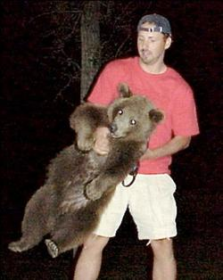
- I am a farmer.

Opdracht 5.

1. Bill is in a shop and wants to buy some sugar for his grizzly. What does he say to the shopkeeper?
- I will get some sugar.
- May I have some sugar, please?
- Did you have some sugar yesterday?
- Shall I buy some sugar next week?
- I’ll come around tomorrow.

- The shop-assistant doesn’t have any sugar left. What does he say?
- I have some sugar.
- Take the sugar from over there.
- The sugar is in the corner.
- Sorry, I haven’t any to day.
- There you are, sir.

- When Bill hears this he is very sad and says……………………………
- What a pity!
- I’m not sorry.
- Excuse me!
- How nice. That’s god.
- I’m sorry.

- The shop-assistant offers Bill some good honey. What does he say?
- What’s the matter with the honey?
- What would you like?
- What about this awful honey?
- Why don’t you give me some honey?
- Would you like some honey instead?

- Bill takes two pounds of honey and says…………………..
- No, I’ve plenty at home.
- No, sugar is better.
- That’s a good idea.
- So do I.
- What’s the matter?

ANTWOORDBLAD.

Naam:……………………………………………………………

Datum:…………………………..

Klas:…………………………..

Part A Part B Part C Part D

1……………… 1…………. 1…………. 1………….

2.………… 2.………… 2.………… 2.…………

3.………… 3. ………… 3. ………… 3………….

4…………… 4…………. 4…………. 4………….

5.………… 5.………… 5.………… 5.…………

6. ………… 6. ………… 6.…………

7.………… 7.………… 7.…………

8.………… 8.………… 8.…………

9.………… 9 ………… 9.…………

10.………… 10.………… 10.………

