[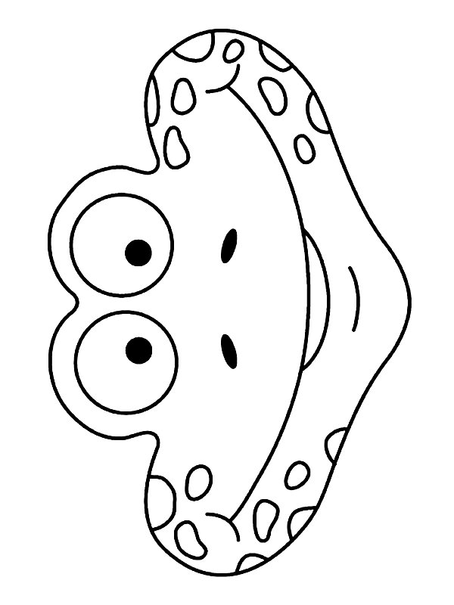](http://www.google.nl/url?sa=i&rct=j&q=&esrc=s&source=images&cd=&cad=rja&uact=8&ved=0ahUKEwjCu-3wg-vLAhVFpQ4KHahWBkYQjRwIBw&url=http://www.kids-n-fun.nl/Knutsels/Maskers-Dieren&psig=AFQjCNFFtGHtXuWFeht0xIUY8yif1yKsqw&ust=1459517145298569)[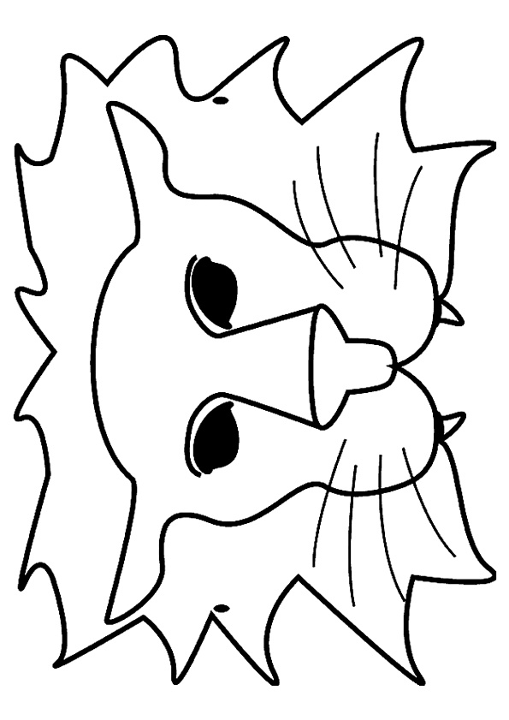](https://www.google.nl/url?sa=i&rct=j&q=&esrc=s&source=images&cd=&cad=rja&uact=8&ved=0ahUKEwiitargg-vLAhWHwQ4KHSnxAjEQjRwIBw&url=https://www.pinterest.com/yolpin/carnaval/&psig=AFQjCNFFtGHtXuWFeht0xIUY8yif1yKsqw&ust=1459517145298569)

[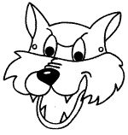](https://www.google.nl/url?sa=i&rct=j&q=&esrc=s&source=images&cd=&cad=rja&uact=8&ved=0ahUKEwjMk5uhhOvLAhXDGg4KHTFCCNAQjRwIBw&url=https://www.pinterest.com/veerlegalle/de-wolf-en-de-7-geitjes/&psig=AFQjCNFFtGHtXuWFeht0xIUY8yif1yKsqw&ust=1459517145298569)

[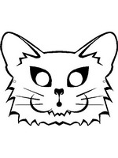](http://www.google.nl/url?sa=i&rct=j&q=&esrc=s&source=images&cd=&cad=rja&uact=8&ved=0ahUKEwjJ_5DUhOvLAhVBcg8KHcZQDf8QjRwIBw&url=http://www.kids-n-fun.nl/Knutsels/Maskers-Dieren&bvm=bv.118353311,d.ZWU&psig=AFQjCNH0Lk_ED4_oWFEcXXRTZpoHb_x3Hw&ust=1459517509463912)

[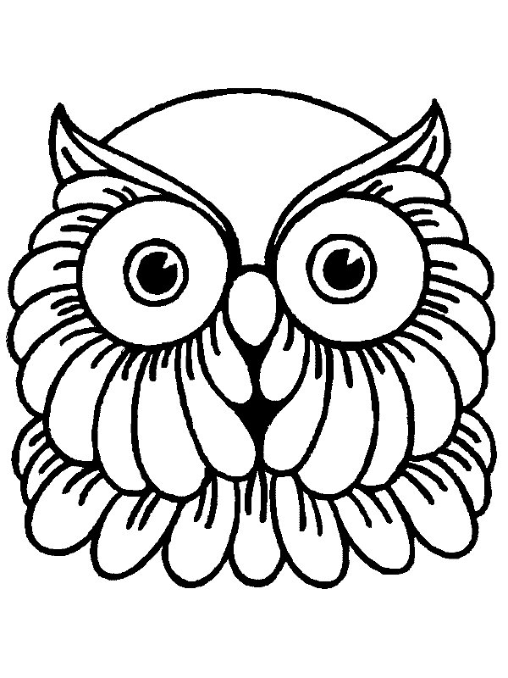](http://www.google.nl/url?sa=i&rct=j&q=&esrc=s&source=images&cd=&cad=rja&uact=8&ved=0ahUKEwjsve31hOvLAhXDYg8KHWV9AKcQjRwIBw&url=http://www.kids-n-fun.nl/Knutsels/Maskers-Dieren&bvm=bv.118353311,d.ZWU&psig=AFQjCNGPHt-S4dV5iX9Lg3hWJRD4yGVrUw&ust=1459517588633375)

[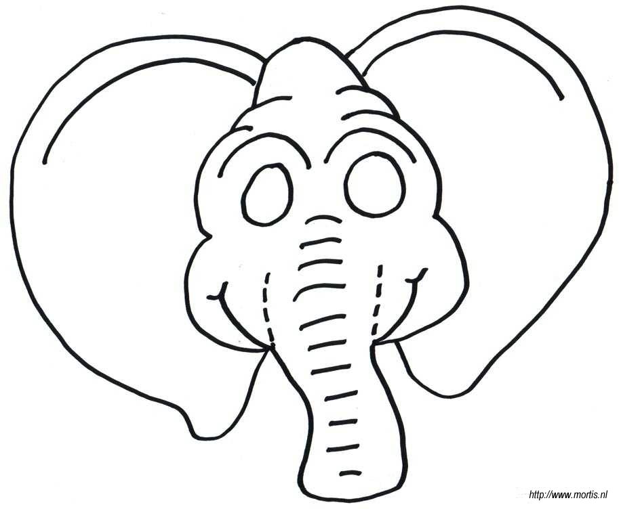](http://www.google.nl/url?sa=i&rct=j&q=&esrc=s&source=images&cd=&cad=rja&uact=8&ved=0ahUKEwikq_eRhevLAhXEfA8KHSgWDJcQjRwIBw&url=http://knutsel.minimahulp.nl/plaat28.html&bvm=bv.118353311,d.ZWU&psig=AFQjCNFfKRw9TV_VjJqh4-0vGZwQbvc7xA&ust=1459517656542017)

[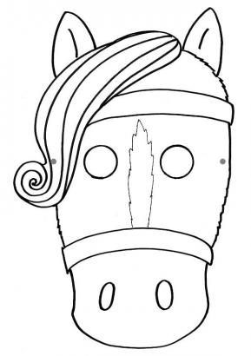](http://www.google.nl/url?sa=i&rct=j&q=&esrc=s&source=images&cd=&cad=rja&uact=8&ved=0ahUKEwiN-cuxhevLAhXEeg8KHVNxDJcQjRwIBw&url=http://www.nataschastenvert.nl/index.php?tid%3D11%26pid%3D83&bvm=bv.118353311,d.ZWU&psig=AFQjCNGnpoAoGeOpcqA9osx895z5uWnl5Q&ust=1459517728261706)

[](http://www.google.nl/url?sa=i&rct=j&q=&esrc=s&source=images&cd=&cad=rja&uact=8&ved=0ahUKEwjynqC8g-vLAhVCYA4KHc37CjEQjRwIBw&url=http://www.leukvoorkids.nl/kleurplaten/dierenmaskers-kleurplaten/&psig=AFQjCNFFtGHtXuWFeht0xIUY8yif1yKsqw&ust=1459517145298569)