**Change in the Amount of Nanoparticles in Nanoproducts After Washing**

|  |
| --- |
| **Materials** |

|  |  |
| --- | --- |
| Macintosh HD:Users:busraacikel:Desktop:NanoProducts.png | 5x5 cm piece of a textile product with AgNP (a towel, a sock, a cloth, etc.) |
| **HD:Users:busraacikel:Downloads:500ml-science-beaker.jpgHD:Users:busraacikel:Downloads:500ml-science-beaker.jpgHD:Users:busraacikel:Downloads:500ml-science-beaker.jpg** | 3 500-mL beakers |
|  | ~ 1 L distilled water |
|  | Glass rod |
| Macintosh HD:Users:busraacikel:Desktop:Termometre.png | Thermometer |
| **HD:Users:busraacikel:Downloads:133620443_tn24_0.jpg** | Heat source |
|  | Tweezers |
|  | Tongs |

|  |
| --- |
| **Procedure** |

**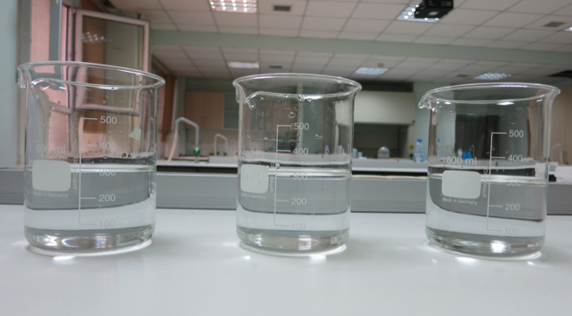**

Put ~300 mL of distilled water in each of the 500-mL beakers.

1. Put one of the beakers on the heater and heat the water to 60°C.

**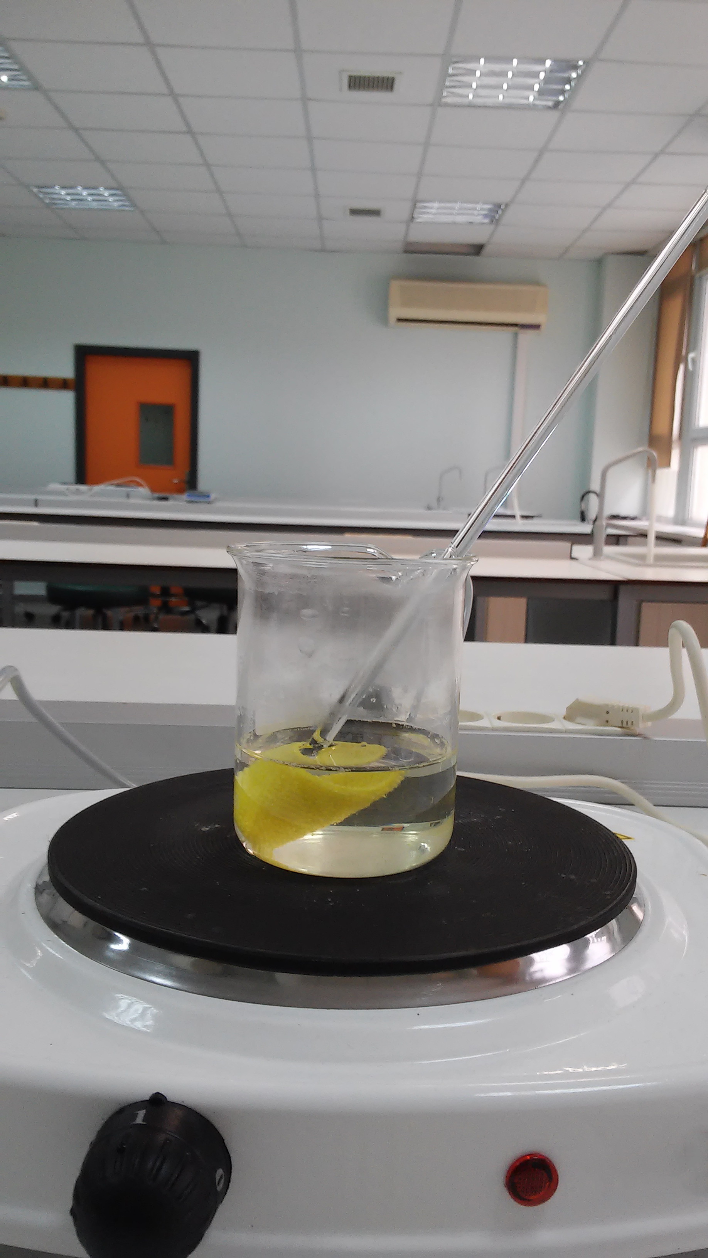**

Put the textile product in the beaker for the first washing process, stirring occasionally for 10 minutes.

**Note 1:** In order to keep the temperature at 60°C, take the beaker from the heater occasionally by using the tongs. Return it to the heater when the temperature starts to drop.

**Note 2:** While you are carrying out the 1st washing process, put the second beaker on the heater and heat it to60°C.

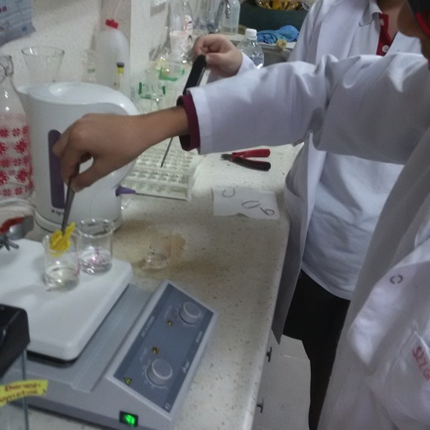

When the washing process is completed, move the nanoproduct into second beaker, using tweezers. Carry out the 2nd washing process, stirring occasionally for 10 minutes.

**Note:** While you are carrying out the 2nd washing process, put the third beaker on the heater and heat it to 60°C.

1. When the 2nd washing process is complete, put the nanoproduct into the third beaker, using tweezers.
2. Carry out the 3rd washing process, stirring occasionally for 10 minutes.
3. Repeat the washing procedure 10 times, using the steps in 3-4 or 5-6.
4. Dry the textile products you have washed.
5. Put the textile samples and the wash water in suitable storage containers, label them, and have them analyzed for Ag+ ions.