**Modeling Drug Release or Absorption with Agar Cubes**

|  |
| --- |
| **Materials** |

|  |  |
| --- | --- |
| **HD:Users:busraacikel:Downloads:500ml-science-beaker.jpgHD:Users:busraacikel:Downloads:500ml-science-beaker.jpgHD:Users:busraacikel:Downloads:500ml-science-beaker.jpg** | Three 500 mL beakers |
| **HD:Users:busraacikel:Desktop:hydrochloric-acid-laboratory-bottle-.png** | ~1000mL 0.2 M HCl solution |
|  | 3 agar cubes of the same volume as 0.1 M NaOH and 1% phenolphthalein (one side of the cubes should be at least 3 cm)  (Examine APPENDIX 2_Preparing Agar Cubes for preparation of the cubes) |
|  | 100 mL Graduated Cylinder |
|  | Ruler |
| **HD:Users:busraacikel:Downloads:CK-025.jpg** | Knife |
|  | Spatula |

|  |
| --- |
| **Procedure** |

**1.**

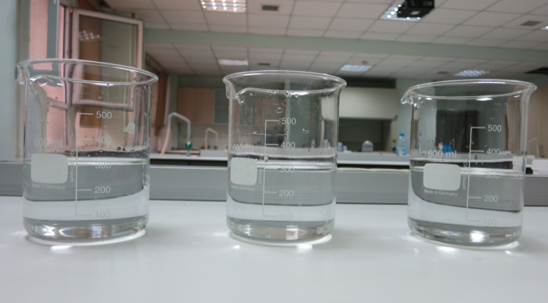

Fill each of the3 beakers with 300 mL 0.2 M HCl solution.

**2.**

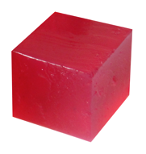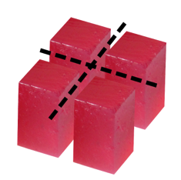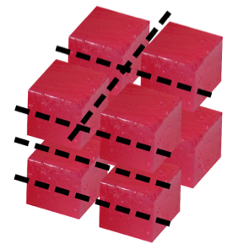

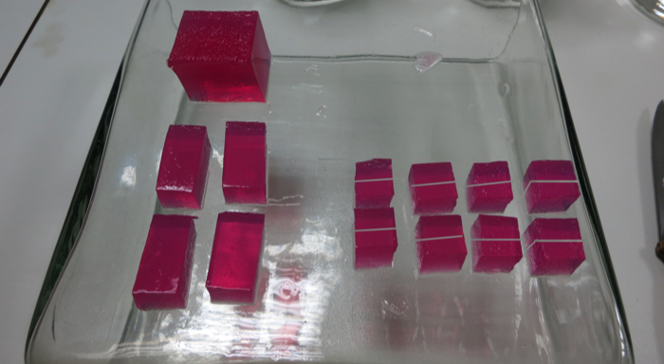

Leave the first agar cube whole, split the second agar cube into 4 pieces, and cut the third cube into 16 pieces.

**3.**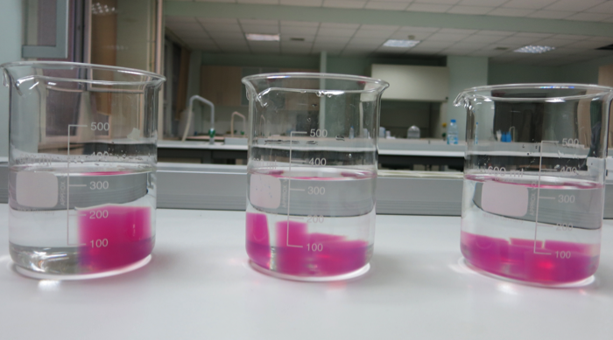

Put the firstagar cube into the first beaker, the agar cube split into 4 pieces into the second beaker, and the one split into 16 pieces into the third beaker.

**4.**

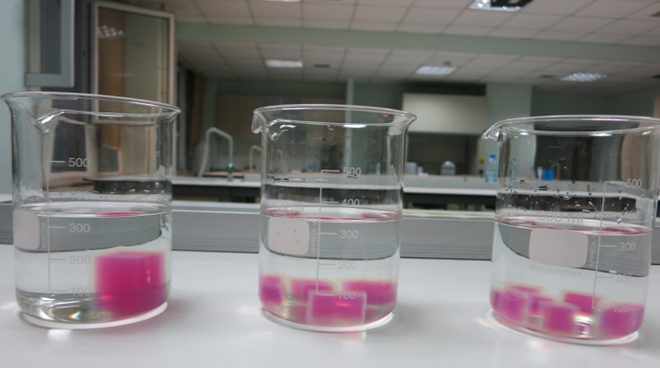

When agar cubes containing a base are put into an acidic solution, a neutralization reaction occurs. As a result of this reaction, fading of color (bleaching) will be observed on the surfaces of the cubes.

**5.**

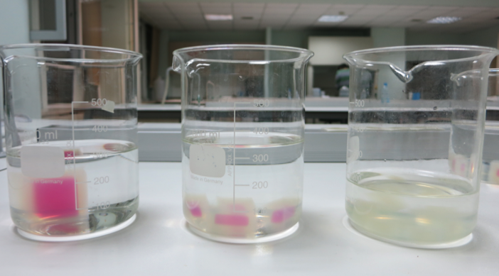

Wait until the 16 pieces of the agar cube lose their color completely. (~15 minutes)

**6.**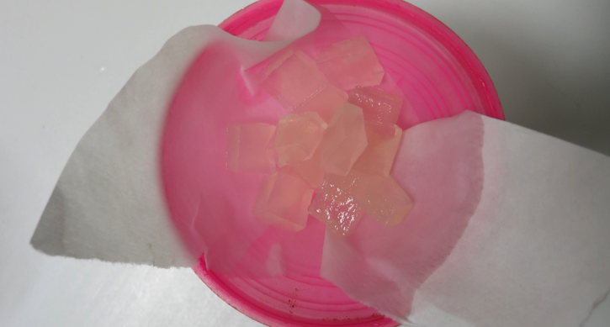

Take the agar cube pieces from the three beakers. You can drain them by using filter paper.

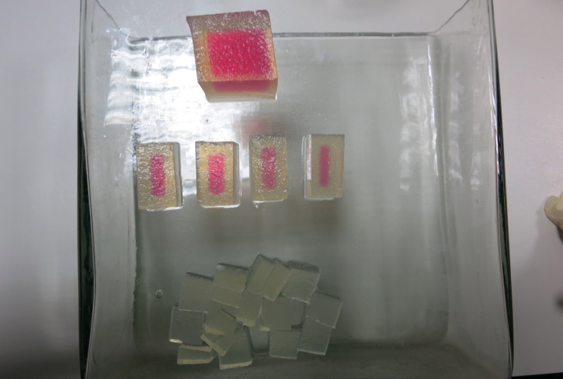

**7.**

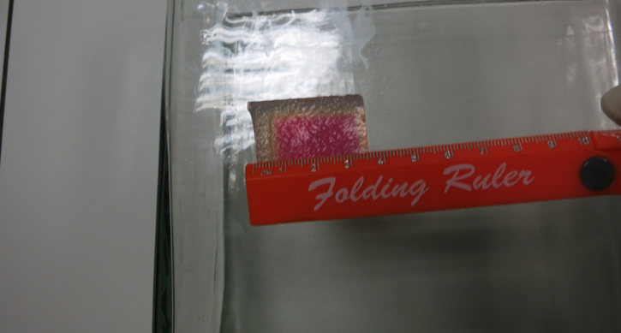

Have your students make the required measurements according to the table in the “Findings” section on the Activity Sheet.