**Preparing Agar Cubes**

|  |
| --- |
| **Materials** |

|  |  |
| --- | --- |
|  | 500 mL distilled water |
|  | 15 g agar |
|  | 5 mL %1 phenolphthalein |
| **HD:Users:busraacikel:Desktop:Agar Cube Preparation:IMG_1192.png** | ~30 mL 0.1 M NaOH solution |
| **HD:Users:busraacikel:Downloads:500ml-science-beaker.jpg** | 500 mL beaker |
|  | Glass rod |
|  | 10mL graduated cylinder |
| **HD:Users:busraacikel:Downloads:images.jpeg** | Digital scale |
| **HD:Users:busraacikel:Downloads:133620443_tn24_0.jpg** | Heat source |
|  | Empty container (ice tray, food container, etc.) |
| HD:Users:busraacikel:Downloads:PLASTIC RULER.jpg | Ruler |

|  |
| --- |
| **Procedure** |

**1.**

**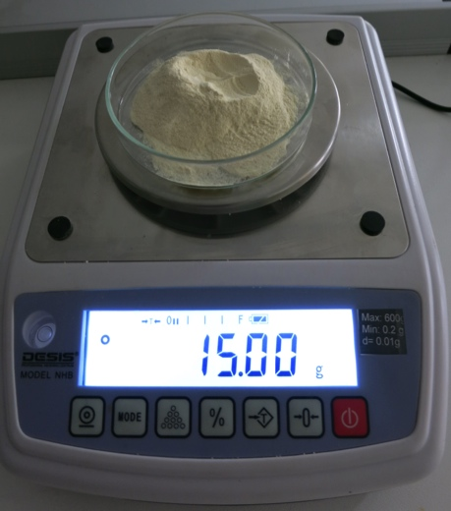**

Weigh 15 g agar.

**2.**

**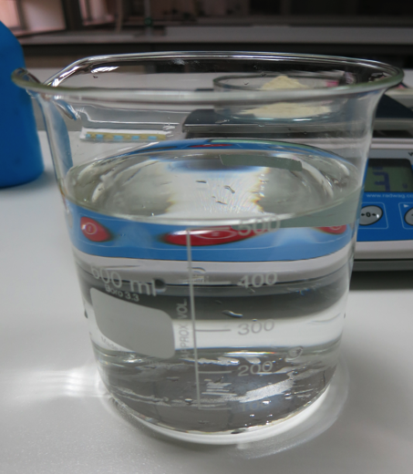**

Add 500 mL distilled water into the500 mL beaker.

**3.**

**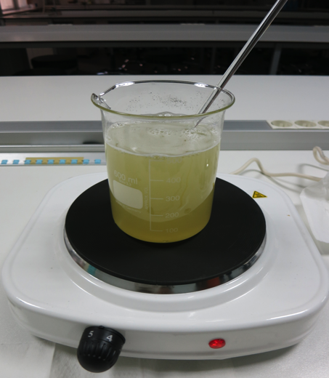**

Add the agar into the distilled water, stirring it with the glass rod as you add it. Then start heating it, stirring it occasionally.

**4.**

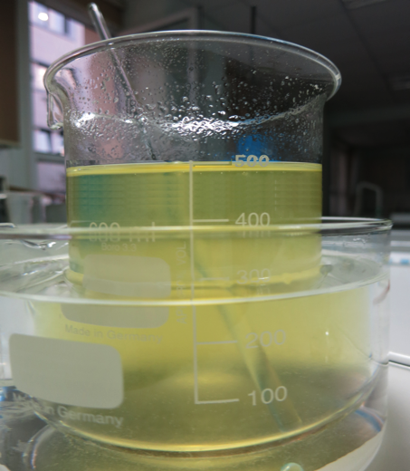

When it is about to boil, take the mixture off the burner and let it cool in a tub of cold water, stirring it occasionally.

**5.**

**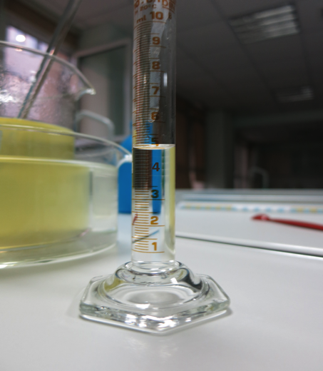**

Add the5 mL 1% phenolphthalein to the agar solution.

**6.**

**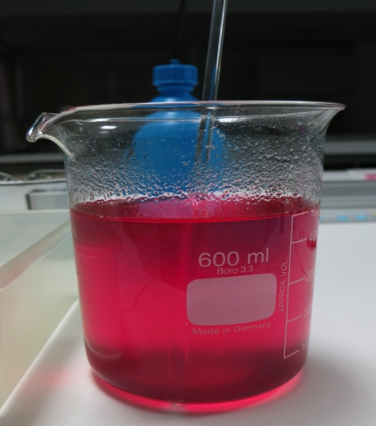**

Add the~30 mL 0.1 M NaOH solution to the mixture.

**7.**

**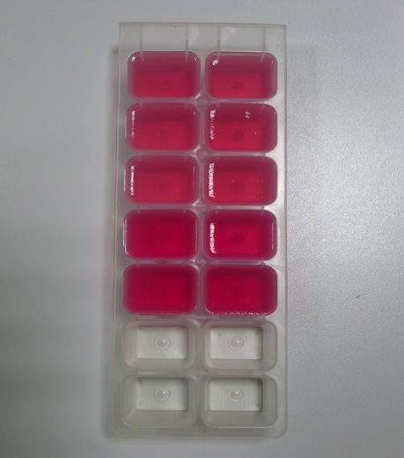**

**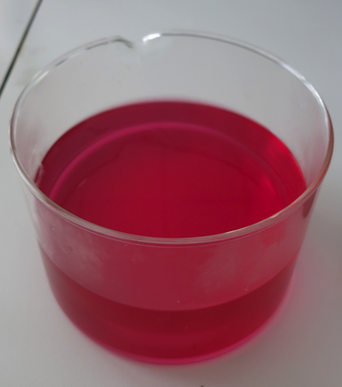**

Put theagar mixture in a container of your choice and let it cool.

**Note:** Using glassware makes it easier to remove the agar.

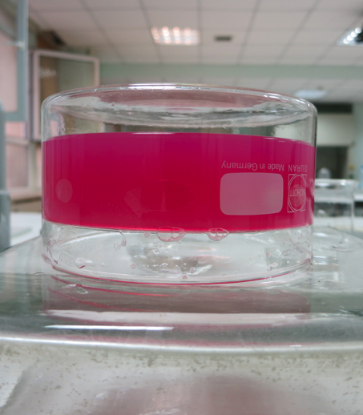

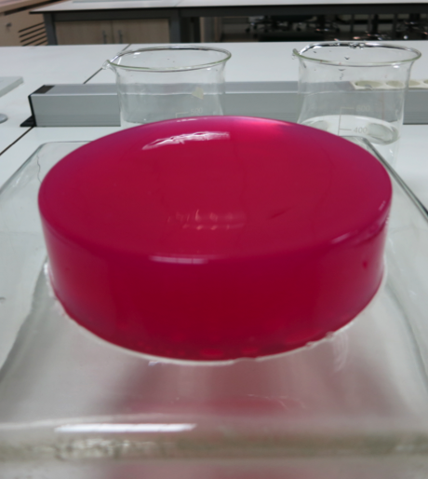

**Note:** If the height of the agar mixture is ~3 cm when you pour it into the container, this will facilitate the preparation of the diffusion activity cubes.

