1. Europe (200km)
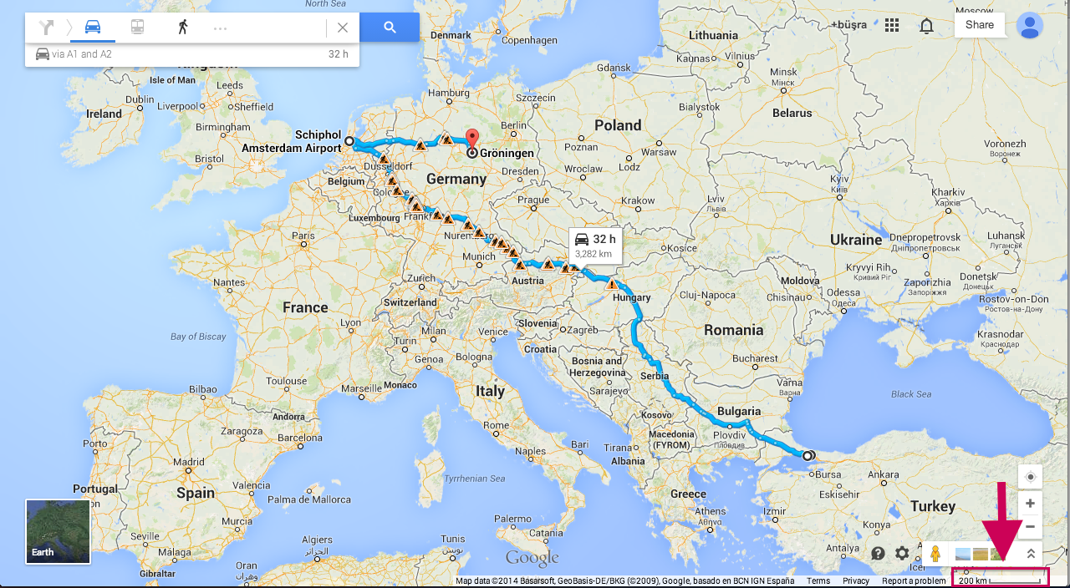

2. Turkey (100km)
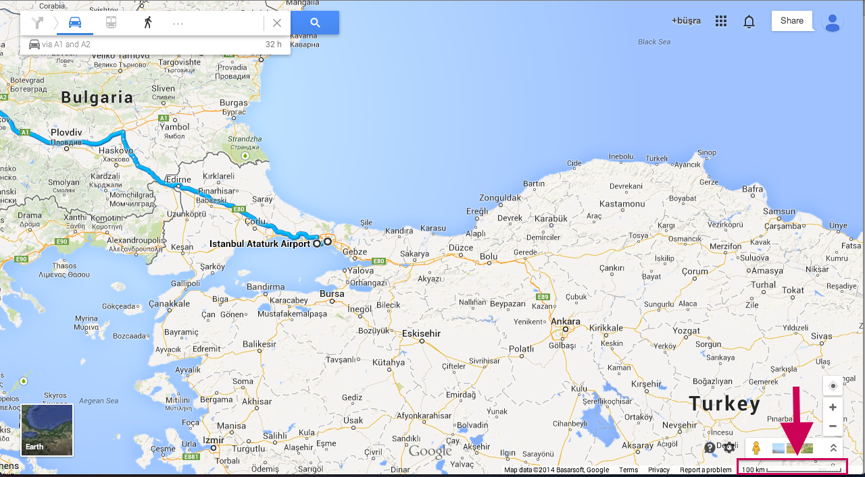
3. European part of Istanbul (10km)
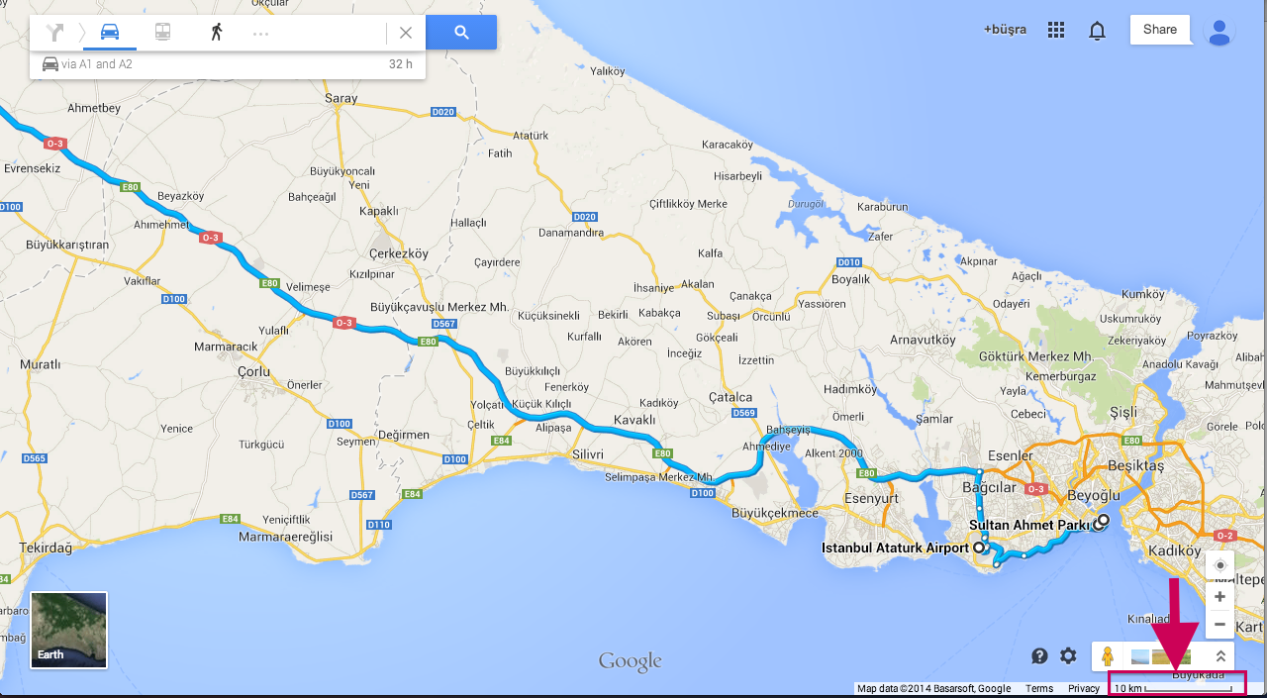

4. Historic Peninsula (1km)
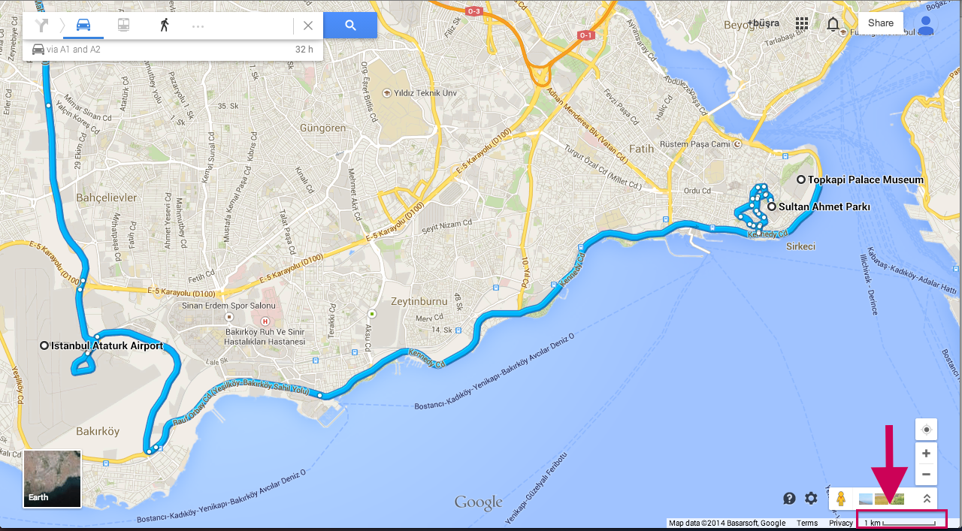
5. Topkapi Palace (100m)
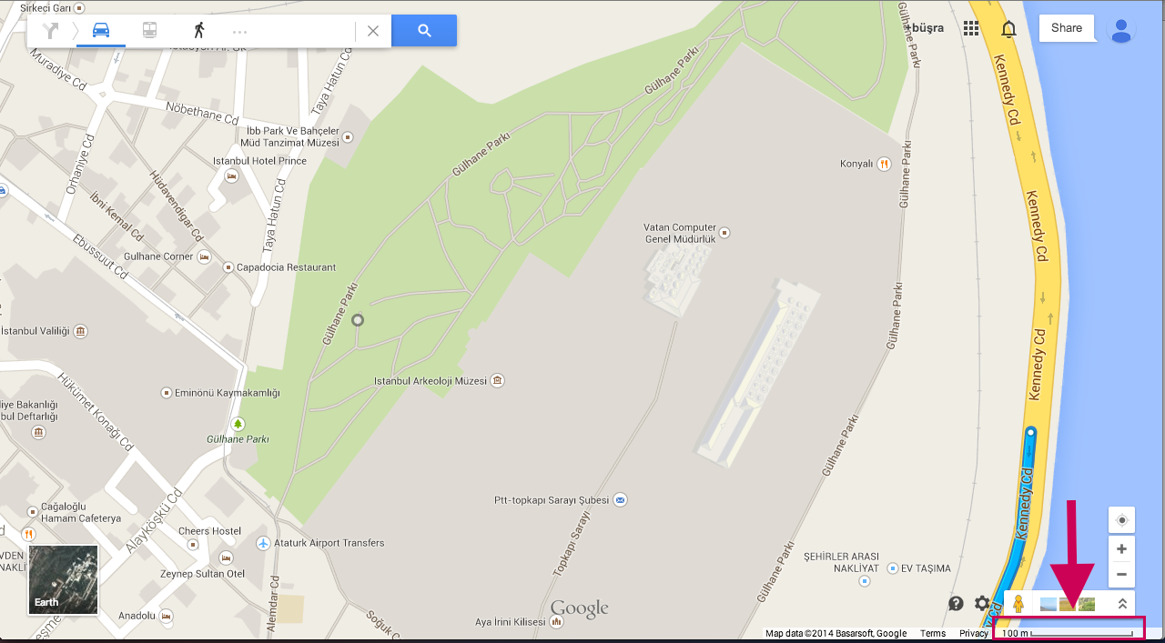

6. Topkapi Palace Satellite View (50m)
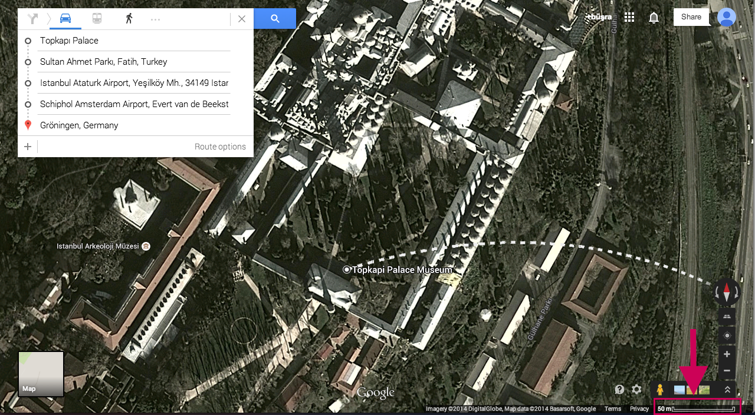
7. Topkapi Palace Entrance (20m)
