**Worksheet A Beijing school day**(adapted from: <http://news.bbc.co.uk/2/hi/in_pictures/6150030.stm>)

You are going to construct a story about a Beijing school day. On these two pages, there are 11 pictures and 11 descriptions. Match the number of the picture (1-11) to the letter of the description (a-k). You can fill your answers in on page 2.

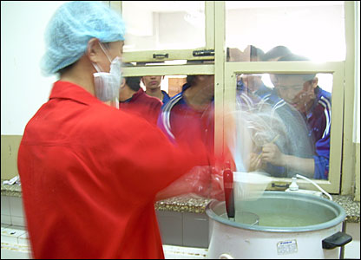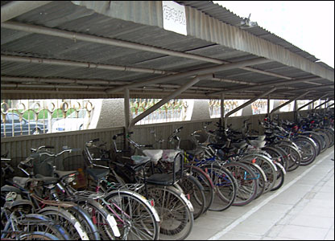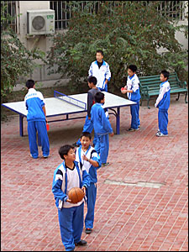

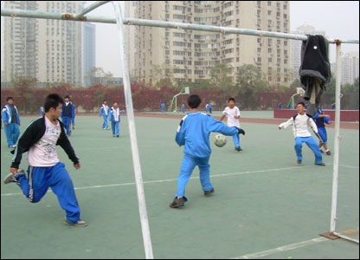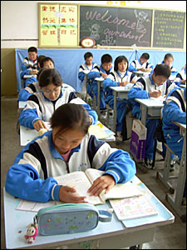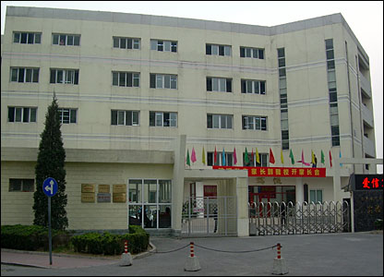 **2.  
 1.   
  
   
 3.**

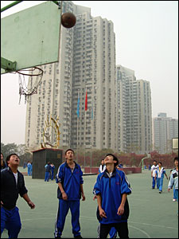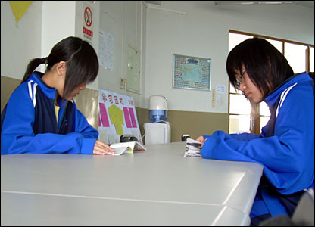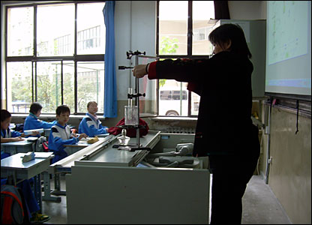 **4.   
  
 5. 6.**

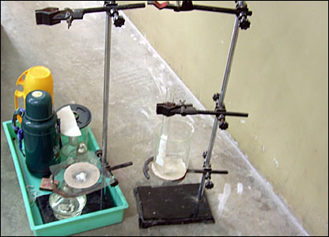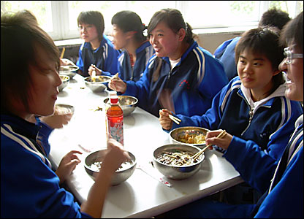 **7.   
  
 8.**

**9.**

**10.**

**11.**

**Descriptions:**

1. Classes begin at 0730 and run until 1700 each day. Subjects include history, geography, maths, languages and citizenship.
2. All the pupils eat in the canteen and take the chance to catch up with their friends, before engaging in a sporting activity or some study.
3. Surrounded by high-rise housing, the school has football pitches, basketball courts and a running track. Time for sport and exercise is built into the school day.
4. Beijing Academy of Educational Science Pilot Middle School is home to more than 800 pupils and 120 teachers. There are more than 200 boarders and the rest are day pupils.
5. The equipment used for the science lesson is basic but functional.
6. Sport plays a big role in the school. The children are keenly awaiting the Olympic Games in 2008.
7. Some children choose to spend their break time in the school library. There is a selection of literature and daily newspapers available.
8. One teacher prepares for a science lesson. The children learn physics, chemistry and biology.
9. Lunch is served just after midday. The menu consists of rice, meat or fish and piping hot noodles.
10. Many of the students who live locally cycle to school. Others can spend several hours getting there daily by bus.
11. Table tennis is a favourite in China and pupils have the use of several tables in the school courtyard.

**Answers:**

1. …
2. …
3. …
4. …
5. …
6. …
7. …
8. …
9. …
10. …
11. …