- What: You need to answer the following questions in English.
- Who is your favourite actor of Skins UK and why?
- What is your favourite episode of the 3 you have seen and why?
- What is/are your favourite scene(s) and why?
- Who has the worst home situation of the three main characters and why?
- What is the most interesting relationship between two characters in Skins and why?

- How: You need to write about one A4 page in Arial 12. After each question please leave open some space. You work together in pairs and you put both your names on the paper. See the other page for an example. (Copying it literally will be plagiarism, so please don’t)
- For what: This will count as a process grade, but it will count 5 times within this type of grading.
- How to get a good grade: besides answering the questions above and handing it on time, a good grade is also the result of a catchy title and a nice lay-out. This will count for about 10% of your grade. You start with a 10 and the most important bit is that I can understand what you’re trying to say with few spelling mistakes on your part. Grammar is less important, but please use the same tense (past simple or present simple).
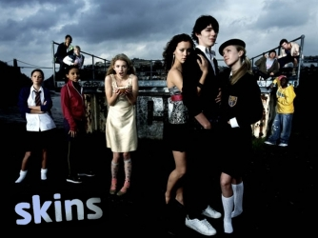
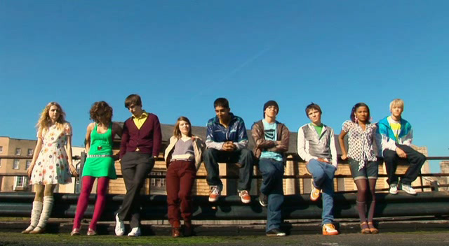
The deadline is on ________________________________________
EXAMPLE OF REVIEW WITHOUT SPOILERS.

Who is your favourite actor of skins UK and why?
Our favourite actor in Skins is Tony. Because he is a very good actor. We also like him because he is more the leader of the group. We also know him from Warm Bodies the movie. In that movie he is also a very good actor. In Skins he is funny and he is a good friend. But not a very good boyfriend.

What is your favourite episode of the 3 you have seen and why?
Our favourite episode was the second one. Because Cassie is a very happy person but it shows you that happy people have problems too. And it was funny to see how ............. (spoiler alert)

What is/are your favourite scene(s) and why?
We like the first scene of the first episode the most. Because it is funny to see how Tony makes his dad ....................... (spoiler alert). And it is nice to see how the rest of the group lives. Because they are all totally different but they still are friends.

Who has the worst home situation of the three main characters and why?
We think that__________________ has the worst home situation. We think that because at home everybody does their own thing. And they have got no interest in each other. And the mom ______________________________________ (spoiler alert)

What is the most interesting relationship between two characters in Skins and why?
We think that Tony and Sid have the most interesting relationship. We think that because they are totally different, Tony is the ___________________. Sid is more a l_________________________..
But even though they are different they are good friends. That is nice to see.
Student A & B –H3A/H3B

