Worksheet A Beijing school day
(adapted from: http://news.bbc.co.uk/2/hi/in_pictures/6150030.stm)
You are going to construct a story about a Beijing school day. On these two pages, there are 11 pictures and 11 descriptions. Match the number of the picture (1-11) to the letter of the description (a-k). You can fill your answers in on page 2.
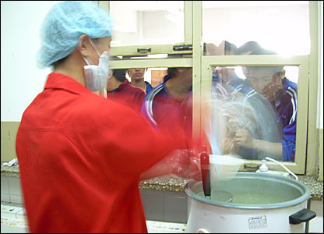
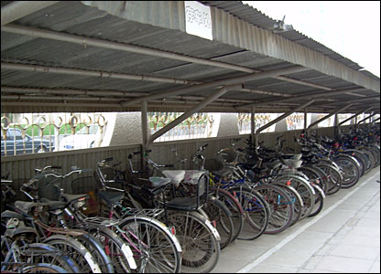
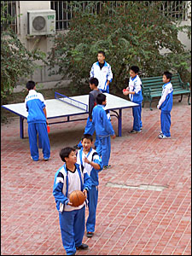

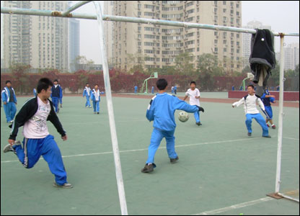
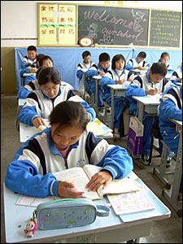
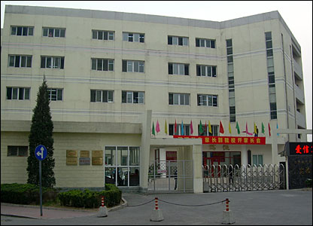
2.
1.
3.

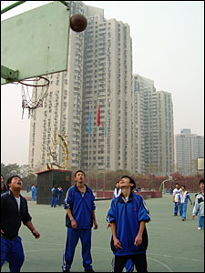
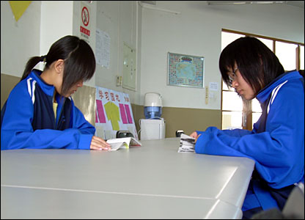
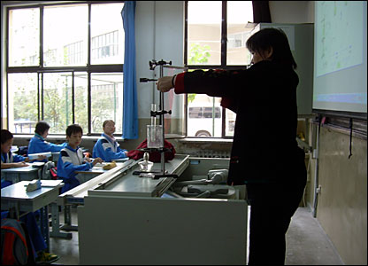
4.
5. 6.

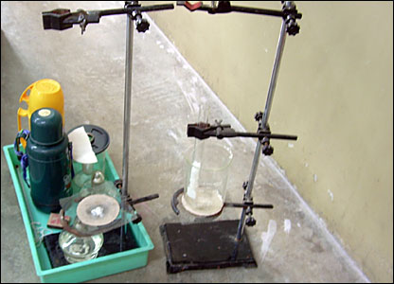
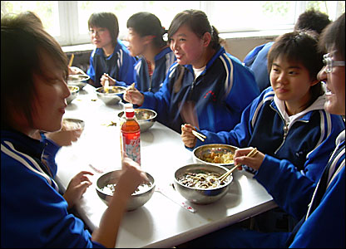
7.
8.

9.
10.
11.
Descriptions:
- Classes begin at 0730 and run until 1700 each day. Subjects include history, geography, maths, languages and citizenship.

- All the pupils eat in the canteen and take the chance to catch up with their friends, before engaging in a sporting activity or some study.

- Surrounded by high-rise housing, the school has football pitches, basketball courts and a running track. Time for sport and exercise is built into the school day.

- Beijing Academy of Educational Science Pilot Middle School is home to more than 800 pupils and 120 teachers. There are more than 200 boarders and the rest are day pupils.

- The equipment used for the science lesson is basic but functional.

- Sport plays a big role in the school. The children are keenly awaiting the Olympic Games in 2008.

- Some children choose to spend their break time in the school library. There is a selection of literature and daily newspapers available.

- One teacher prepares for a science lesson. The children learn physics, chemistry and biology.

- Lunch is served just after midday. The menu consists of rice, meat or fish and piping hot noodles.

- Many of the students who live locally cycle to school. Others can spend several hours getting there daily by bus.

- Table tennis is a favourite in China and pupils have the use of several tables in the school courtyard.

Answers:

- …
- …
- …
- …
- …
- …
- …
- …
- …
- …
- …

