Grieks alfabet

Grieks alfabet
Α | α |  | alfa | Ν | ν |  | nu
Β | β |  | bèta | Ξ | ξ |  | xi
Γ | γ |  | gamma | Ο | ο |  | omikron
Δ | δ |  | delta | Π | π |  | pi
Ε | ε |  | epsilon | Ρ | ρ |  | rho
Ζ | ζ |  | zèta | Σ | σ | ς | sigma
Η | η |  | èta | Τ | τ |  | tau
Θ | θ |  | thèta | Υ | υ |  | ypsilon
Ι | ι |  | iota | Φ | φ |  | phi
Κ | κ |  | kappa | Χ | χ |  | chi
Λ | λ |  | lambda | Ψ | ψ |  | psi
Μ | μ |  | mu | Ω | ω |  | omega

Mummificeren

Bier brouwen

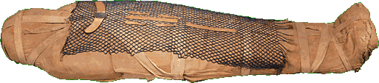
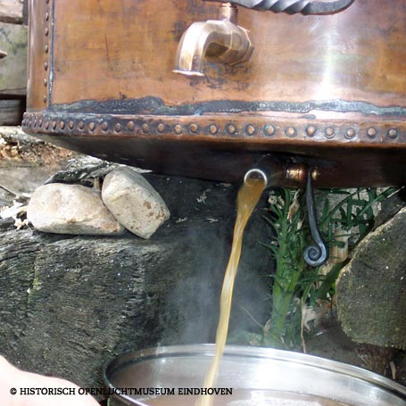

Hunebedden

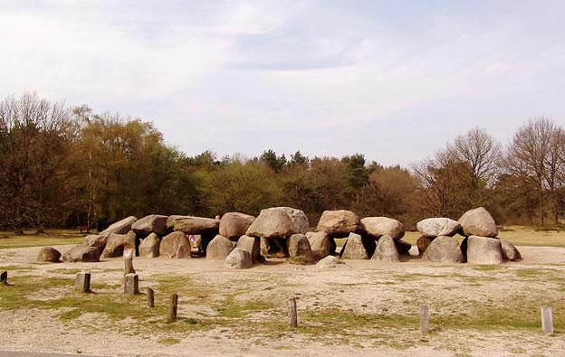

Spijkerschrift

Glas

Houtenwiel
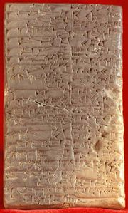
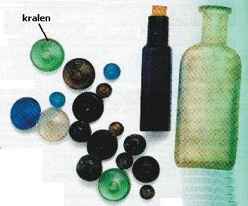
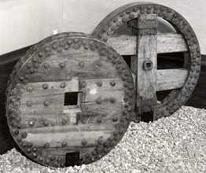

Spaakwiel

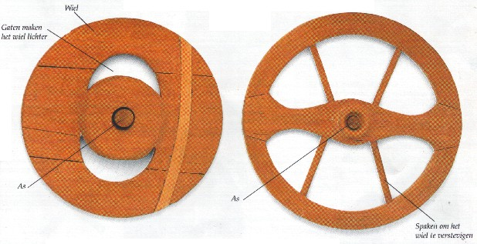

4500 v. Christus 4000 v. Christus 3200 v. Christus 3000 v. Christus 2000 v. Christus 900 v. Christus

