Pricing
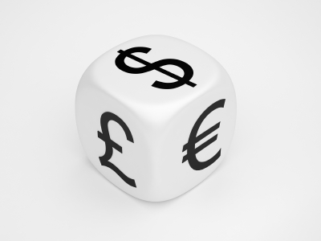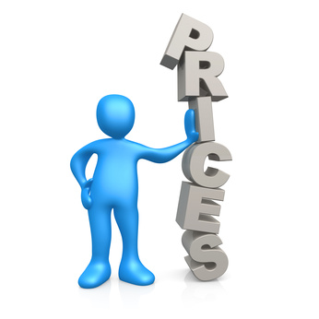
If the other fellow sells cheaper than you, it is called dumping. 'Course, if you sell cheaper than him, that's mass production.’
  - Cost-based Pricing
Each of the three cost-based pricing methods described begin with a product cost subtotal. To calculate product cost you need to include the costs of operating the business, which could include raw materials, transportation, advertising, wages, rent and other costs incurred in producing the product. Once you have a base cost, then add the profit level you want for the business to the product cost subtotal to determine your product price. The amount of profit you add to the product cost subtotal can be set according to the following three different methods:
- include a profit percentage with product cost (mark-up pricing)
- add a percentage to an unknown product cost (cost-plus pricing)
- price is a blend of total profit and product cost (planned-profit pricing

All types of cost-based pricing will be more accurate if you use a complete product cost subtotal. The key to accuracy is to ensure all cash and non-cash costs (raw material, labour and overhead/operating costs) are included in the product cost subtotal. You need to set a value for your management expertise and labour. The use of your land or capital equipment also must be valued along with depreciation on your machinery and buildings. These values are included in the product cost subtotal.
Include a profit percentage with product cost
Marketers call this method mark-up pricing. Mark-up pricing is favoured by businesses with many products because it is simple to calculate. The profit level you want for the business is expressed in a percentage. This percentage is added to the production cost to set product price. Mark-up pricing is common in retail business because of so many types of products and purchases from many vendors.
Example:
Wild Blue Preserves makes 15 different jams and jellies. They set up a small shop in a local mall to sell their products alongside other prepared foods. A jar of wild blueberry jelly costs $1.50 per 250 ml jar to produce. The mark-up pricing percentage Wild Blue Preserves plans to use is 40 per cent. The jar of jam will cost $ 2.10 in the shop.
Add a percentage to an unknown product cost
This type of pricing is often called cost-plus pricing. Cost-plus pricing works well if you do not know your production costs. This method is very similar to mark-up pricing. The big difference between mark-up pricing and cost-plus pricing is that both buyer and seller settle on the profit figure or percentage, accepting that the cost of production is an unknown. If you produce custom order products for other firms or individuals, a cost-plus pricing method could reduce your risk. Rather than take a risk on input costs increasing during the project, you could use a cost-plus pricing agreement.
Example:
You have agreed to act as a co-packer for a start-up snack food business, packaging and distributing low-fat energy bars. As a co-packer, you will purchase ingredients through your suppliers, but you are unsure of input costs. The snack food business signs a contract with you to pay for materials costs plus a processing cost of $25 per case.
Price is a blend of total profit and product cost
Otherwise known as planned profit pricing, this method ensures you will earn a total profit for the business. It differs from the first two types of cost-based pricing as they focused on a per unit price. Planned profit pricing combines per unit costs with output projections to calculate product price. Break-even analysis is used to calculate planned profit pricing. Planned profit pricing is well suited to manufacturing businesses. A manufacturer often has the ability to increase or lower production depending upon the demand or profit available.
Example
A special order cake business could set prices according to the size of the orders they receive from various customers. A price break is given to customers who order 10 or more cakes at a time.
The main advantage of planned profit pricing is that it allows the manufacturer to consider how various levels of output can affect the product price. As well, the manufacturer can examine how various prices will affect the amount of output needed.
Disadvantages of cost-based pricing
Before you select a cost-based pricing option, you should consider the disadvantages. There are two important reasons why cost-based pricing doesn’t work for some businesses:
Cost-based pricing does not consider how customer demand affects price. Demand for a product will directly affect how much people will pay. If, due to heavy demand, customers believe a product is in short supply, they may be willing to pay more. On the other hand, if demand is very low the customer will look for a discount on the price.
Competition is not included in cost-based pricing methods. Competition should affect how you price your product. The idea of simply adding a profit level or percentage to a product price will only work in industries with limited competition. In a competitive market, cost-based pricing may encourage competitors to enter the market with a lower price.
Answer the next questions (in Dutch)
- Which three pricing methods are mentioned in this article?
- What does the author mean with cost subtotal’?
- What are non-cash costs?
- What method is simple to calculate?
- What is the difference between mark-up pricing and cost plus pricing?
- What is the principle of planned profit pricing?
- What is a break-even analysis?
- Mention two disadvantages of cost based pricing.
- When is a customer looking for a discount?
- In what kind of market cost based pricing is not working?

  - Pricing

June's Furniture Price Schedule by Margins
item | wholesale cost | selling price = cost/(1-markup on selling price) |  |  | profit on 50% | profit on 55% | profit on 60%
 |  | 50% | 55% | 60%
sofa | 275,00 | 550,00 | 611,11 | 687,50 | 275,00 | 336,11 | 412,50
lamp | 125,00 | 250,00 | 277,78 | 312,50 | 125,00 | 152,78 | 187,50
end table | 225,00 | 450,00 | 500,00 | 562,50 | 225,00 | 275,00 | 337,50
chair | 215,00 | 430,00 | 477,78 | 537,50 | 215,00 | 262,78 | 322,50
rug | 425,00 | 850,00 | 944,44 | 1.062,50 | 425,00 | 519,44 | 637,50
picture | 100,00 | 200,00 | 222,22 | 250,00 | 100,00 | 122,22 | 150,00
totals | 1.365,00 | 2.730,00 | 3.033,33 | 3.412,50 | 1.365,00 | 1.668,33 | 2.047,50

Discuss with your partner in English how you could realise such a table for price calculation in Excel.
If you need help open the worksheet ´Excel Magic trick 285´.
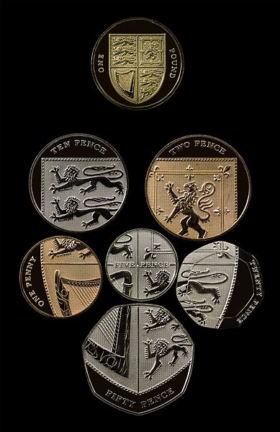
3. The pound sterling (GBP)
All frequently used coins except the £2 coin (coins shown are those after the extensive 2008 redesign).
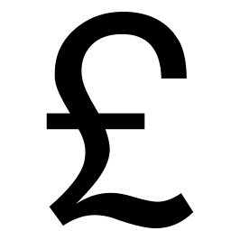
Penny – pence
Pound - pounds

1 EUR = 0.8 GBP

Coin – coins

Pence (p) | Pounds (£)
1p | £ 1
2p | £ 2
10 p
20p
50p
Banknotes
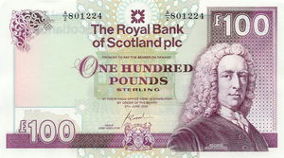 | 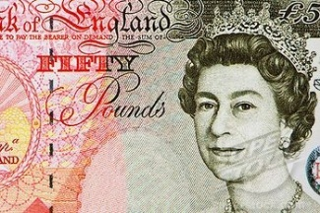 | 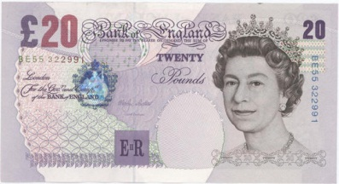
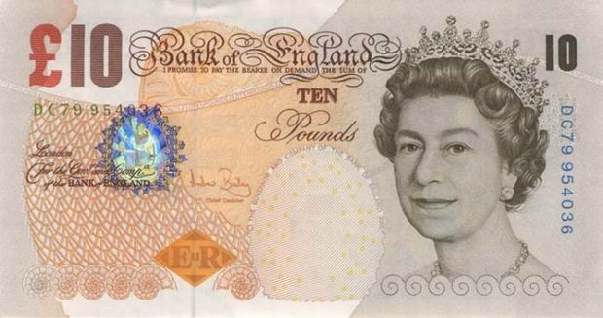 | 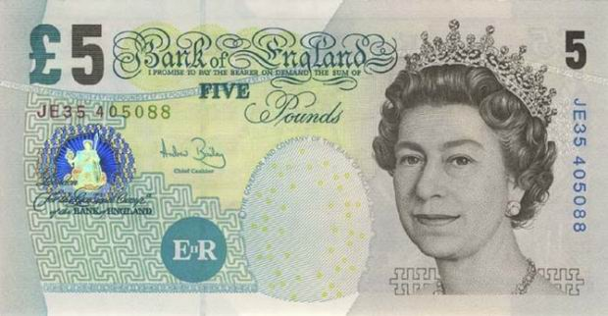

Fill out next form/table.
Return and change
Cost - price | Payd with | Change | ±Value in euro’s
£ 3.75 | £ 5 | £ 1 + 20p+2p+2p+1p | € 4,31
£ 88 | £ 50+£ 50
£ 34 | £ 20+£ 20
£ 26.50 | £ 20+£ 10
£ 1.95 | £ 2
£ 0.65 | £ 1
£ 55 | £ 50+£ 20
£ 73.40 | £ 50+£ 50
£ 0.25 | 50p
£ 6.85 | £ 10

- Work order
Try to realise the order below in Excel. Cooperate with your partner and help each other. Instructions in English please.
Of course you may ask your teacher for help.
There is no example to copy, so you have to do it on your own.
Good Luck!

[Company Name / Logo] |  |  |  | WORK ORDER
 |  |  |  |  | W.O. # : | [123456]
[Street Address] |  |  |  |  | W.O. Date : | 22-12-2010
[City, ST ZIP]
Phone: [000-000-0000] |  |  |  | Requested By : | [Customer Name]
Fax: [000-000-0000] |  |  |  | Customer ID : | [abc1]
[Web Address] |  |  |  | Department :
JOB |  |  | BILL TO |  | SHIP TO (if different)
[Enter description of work] |  |  | [Name] |  | [Name]
 |  |  | [Company Name] |  | [Company Name]
 |  |  | [Street Address] |  | [Street Address]
 |  |  | [City, ST ZIP] |  | [City, ST ZIP]
 |  |  | [Phone] |  | [Phone]
QTY | DESCRIPTION |  |  | TAXED | UNIT PRICE | LINE TOTAL
15 | Part XYZ |  |  | x | 150,00 | 2.250,00
5 | Hourly Labour for ABC (5 hours) |  |  |  | 50,00 | 250,00
 |  |  |  |  |  | -
 |  |  |  |  |  | -
 |  |  |  |  |  | -
 |  |  |  |  |  | -
 |  |  |  |  |  | -
 |  |  |  |  |  | -
 |  |  |  |  |  | -
 |  |  |  |  |  | -
 |  |  |  |  |  | -
 |  |  |  |  |  | -
 |  |  |  | [42] | SUBTOTAL | $ 2.500,00
Other Comments or Special Instructions |  |  |  |  | TAXABLE | 2.250,00
1. Total payment due 30 days after completion of work |  |  |  |  | TAX RATE | 6,875%
2. Please refer to the W.O. # in all your correspondence |  |  |  |  | TAX | $ 154,69
3. Please send correspondence regarding this work order to: |  |  |  |  | S & H | $ -
[Name, Phone #, Email] |  |  |  |  | OTHER | $ -
 |  |  |  |  | TOTAL | $ 2.654,69
 |  |  |  |  | Make checks payable to
 |  |  |  |  | [Enter Company Name]
 | I agree that all work has been performed to my satisfaction.
 |  |  |  | Completed Date:
Signature: |  |  |  | Date:
Thank You For Your Business!

- Watch the film
Telephone etiquettes an manners
Answer the next questions.(Dutch)
- What stuff the shopping bag is made of?
- How soft are the pencils?
- Why do you need tracing paper?
- What kind of paint she uses?
- What does she use the tissue for?
- Why does she need the card board?
- How long has the paint to be dried?
- Why does she use the brush first en later on the nozzle?
- Before ironing you have to wait a long time; how many hours?
- How short must last the ironing?

2. Telephone Watch the film ´Telephone etiquettes and manners´
On the next page you will find three telephone calls. Fill the blanks.
Practice 1: Making an Appointment
Receptionist: Thank you for phoning Maple Dental Clinic. Sylvia …………… . How can I help you? (calls, speaking, speaks)

Thelma: Hi Sylvia. ………………Thelma Woods calling. How are you today? (I am, It’s, This be)
Receptionist: I'm fine Mrs. Woods. How are you?

Thelma: Well, actually, I have a bit of a sore tooth. I was hoping Dr. Morris would have some time to see me this week.

Receptionist: I'm ……………….. he's booked this week. I can put you in for 2pm next Tuesday. How does that sound? (afraid, scared, worried)
Thelma: That would be great.

Receptionist: I'll have to give you the address of our new office.

Thelma: Oh, that's right, you moved.

Receptionist: Yes, we moved downtown. Do you have a ……………………………… ? (the available pen, the handy pen, pen handy)

Thelma: Could you hold on a ……………………please. ...Okay, go ahead Sylvia. (buzz, moment, time)

Receptionist: Okay, we are at 723 Baltic Avenue. Suite 004.
Thelma: ………………………..spelling that for me? (Would you mind, If you could, Please can you)

Receptionist: Sure. That's seven-twenty-three Baltic--B ………………… A as in Alpha, L as in Lima, T as in tango, I as in India, and C as in Charlie. And it's suite zero zero four. (for Bear, as in Brave, as in Bravo)
Thelma: Okay great. I'll see you on Tuesday then.

Receptionist: Okay. ………………..calling. See you then. (Great for, Pleased to, Thanks for)

Thelma: Thanks. Bye.

Practice 2: Taking a Message

Leslie: ………………….. (Hello?, Hi, Yes)

Cameron: Hi, ……….. is this Leslie?
Leslie: Yes. ? …………………………. (Who are you?, And you?, Who’s this?)

Cameron: It's Cameron here. Is Maria …………………….. ? (inside, in, where)

Leslie: No, she just …………………. out for a moment. Can I take a message? (came, stepped, gone)
Cameron: Yes, thanks. …………………. ask her to meet me at the Capitol 4 movie theatre at 7 pm tonight? (Could you, Would you mind, Can you be)
Leslie: Sure. Just let me write that down. Oh Cameron. Could you ………………….. for a second? I have to take another call. (hold off, holding, hold)
Cameron: No problem.
Leslie: Hi. Sorry about that. Now could you please that information? I didn't have a pen handy.
Cameron: Sure. It's the Capitol 4 theatre at 7 o'clock.

Leslie: Okay, I've got it. Is there anything else?

Cameron: No, that's great.

Leslie: Okay. Uh-oh, there's my other line again. I'd better ……………………….. . (call, run, hang on)

Cameron: Okay, thanks again. Bye for now.

Leslie: ........................(Bye Bye, Bye too, See you again)

Practice 3: Ordering a Pizza

Hostess: Pepi's Pizza. How can ……………….. I call answer help you? (call, answer, help)
Customer: Hi. I'd like to order a pizza please.
Hostess: Okay. I'll have to transfer your call to our take-out department. ………….moment please. (One.This, A)
Recorded
Message: Thank you for calling Pepi's Pizza. All of our operators are busy…………….. . Please hold for the next available person. (working today and away at the moment)
Take-out
Clerk: Thank you for waiting. Naoko ………………... Is this for take-out or delivery? (is here, speaking, talks)
Customer: Delivery please.
Take-out
Clerk: Can I have your name and address please?
Customer: My name is...
Take-out
Clerk: Sorry, it's really busy in here. Could you …………………a little please? (speak out, speaking, speak up)
Customer: Oh, sure. This is Angie Smith. My address is number two Front Street.
Take-out
Clerk: Is that an apartment or a house?
Customer: It's an apartment. Number seventeen.
Take-out
Clerk: Okay. And what would you like to order today?
Customer: I'd like a large pepperoni pizza with mushrooms, olives and extra cheese.
Take-out
Clerk: I'm sorry, my English isn't ……………………….. Could you slow down a little please? (Better, very strong, easy)
Customer: No problem. That's a large pizza.
Take-out
Clerk: Large pizza. Okay.
Customer: And I'd like it with pepperoni and mushrooms.
Take-out
Clerk: Pepperoni and mushrooms. Is there anything else?
Customer: Yes, olives and extra cheese please.
Take-out
Clerk:Okay. I've……………………. . (got your message, got information, got it all down)
Customer: Great. And how long will that be?
Take-out
Clerk: It will be about thirty minutes, Miss Smith.
Customer: And how much will it cost?
Take-out
Clerk: Um--could you please ……………… while I check with the kitchen? (hold off, holding, hold on)
Customer: Don't worry about it. I have to go. I have another call …………………. . Thank you. Bye for now. (came to, come, coming through)
Take-out
Clerk: Okay. Thanks for calling. Bye.

