- Stock – order – purchase
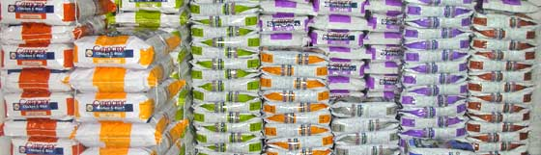
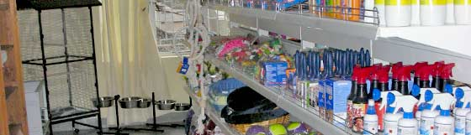
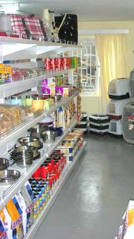

Trade is not about goods. Trade is about information. Goods sit in the warehouse until information moves them.
- Watch the film
Modernizing Inventory Management
Answer the next questions .(Dutch)
- Where is this store situated?
- What is the customer looking for?
- Is the article on stock or not?
- What is the seller doing?
- What is the name of the store?
- When did the sun take over?
- In which year did the father start the business?
- What is the name of the father?
- What is ythe different approach of the sun?
- How many different items are available?
- How many stores are there nowadays?
- What is helpful in keeping track on all items in the stores?
- What is meant by the IT is not a cost but a spend?
- What is the latest pend in IT.

2. The Purchasing Process
Why is it important to have a formal purchasing process? Is it important to have a predefined purchasing process? What can go wrong if the purchasing process is not followed?
There are many reasons why a formal process must be followed including the prevention of fraud, cost saving, compliance with regulations, management of risk and control. To understand or to explain why a formal process should be followed it can be useful to think in terms of the 5 As.
- Approved Suppliers
- Approval Process and Segregation of Responsibilities
- Audit Trail
- Accounting
- Automation
There is sometimes a significant amount of effort required to ensure that a supplier is appropriate for a particular category of goods or services. They should be able to supply goods and services that meet requirements of quality and fit for purpose. They should be reliable financially sound and not present a commercial or reputation risk and their prices should be competitive. It makes no sense to perform the relevant research on a supplier each time goods or services are required. By developing preferred suppliers, longer term sustainable relationships can be developed that deliver a better value for money.

Approval Process and Segregation of Responsibilities
- The principles of approval and segregation of responsibilities provides an organization with a control to reduce the risk of fraud. The requirement for the approval of a purchase requisition prevents inappropriate purchases being made and the separation of responsibilities to unconnected parts of the buying organization helps to reduce the risk of collusion.

Audit Trail
- A formal purchasing process that records a predefined set of processes allows the path of events to be examined retrospectively to identify errors or deliberate breaches of policy.

Accounting
- All commercial organizations have a legal responsibility to account for their finances including for the goods and services that they procure. It is important therefore that proper records are maintained e.g. to record dates, prices and department details as well as to categorize goods and services appropriately to distinguish between capital goods and expenses for example. This can have a crucial bearing on how the finances of the organisation are described which in turn can have a tax and profitability impact.

Automation
- A standard process allows for automation and the use of technology which reduces the cost of the process.

approve | goedkeuren
PO (purchase order) | koopopdracht (order)
request | verzoek
fulfilment | uitvoering
GRNI (Goods Received Not Invoiced) | niet gefactureerde wel geleverde goederen
Accrual | tegenrekening voor ontvangen nog niet gefactureerde goederen
audit trail | controle traject
purchase | aankoop, inkoop
suppliers | leveranciers
appropriate | geschikt
Meet | overeenkomen
requirements | eisen
purpose | doel, opzet
Reliable | betrouwbaar
Sound | gezond
preferred | gewenst
sustainable | duurzame
value for money | waar voor je geld
segregation | scheiding
collusion | heimelijke afspraken
unconnected parts | dingen die eigen leven gaan leiden
retrospectively | terugkijkend
deliberate | opzettelijk
to breach | inbreuk maken
Policy | beleid
to procure | verwerken
to distinguish | onderscheiden
capital goods | investeringen
expenses | uitgaven, kosten
Bearing | invloed

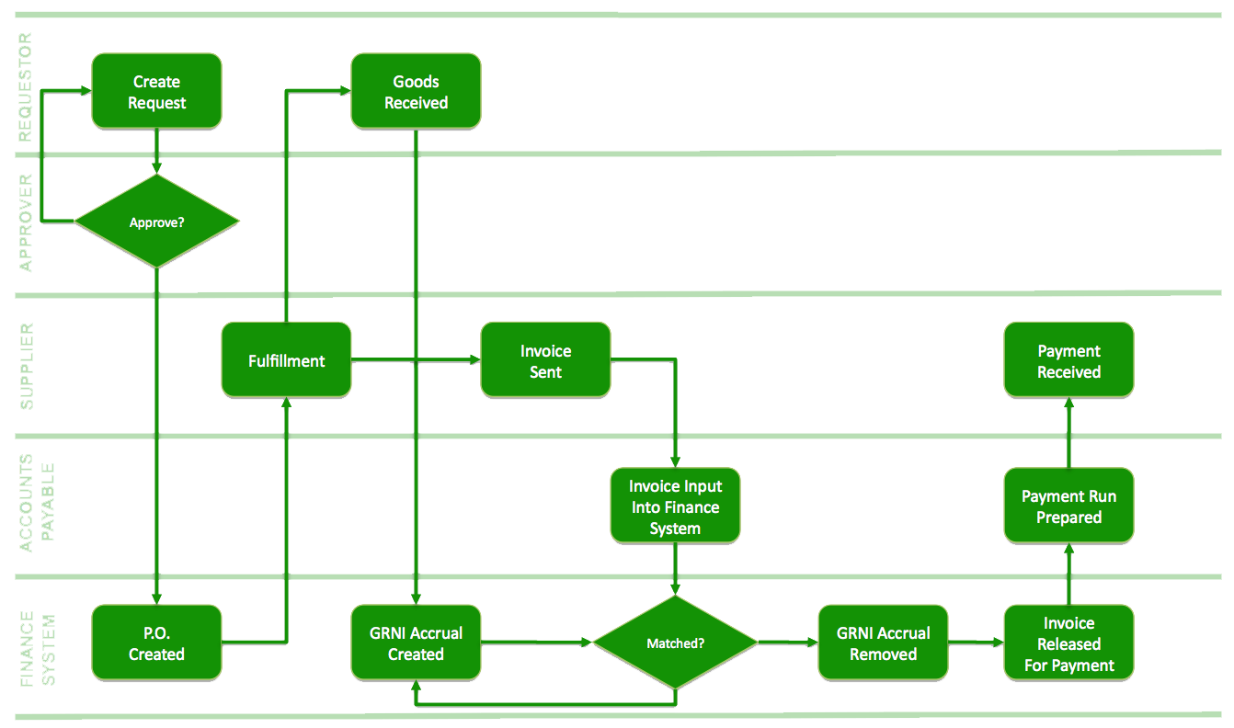

- Dialogue
Write down at least 10 questions to ask your partner about the article above. Write down the given answers. Afterwards discuss the answers. In English please.
Avoid closed questions (yes or no). Use: why, when, who, what, where….

- 50 BASIC ENGLISH QUESTIONS (practice with your partner)
Here are 50 basic (American) English questions with responses.
Personal Information
What's your name? | Peter.
Where are you from? / Where do you come from? | I'm from ... I come from ...
What's your surname / family name? | Smith.
What's your first name? | Tom.
What's your address? | 7865 NW Sweet Street
Where do you live? | I live in San Diego.
What's your (tele)phone number? | 209-786-9845
How old are you? | Twenty-five. I'm twenty-five years old.
When / Where were you born? | I was born in 1961 / Seattle.
Are you married? / What's your marital status? | I'm single.
What do you do? / What's your job? | I'm a florist.
Where did you go? | I went to a friend's house.
What did you do? | We worked in the garden.
Where were you? | I was in New York for the weekend.
Have you got a car / job / house / etc.? | Yes, I've got a good job.
Have you got any children / friends / books / etc.? | Yes, I've got three children - two boys and a daughter.
Can you play tennis / golf / football / etc.? | Yes, I can play golf.
Can you speak English / French / Japanese / etc.? | No, I can't speak Japanese.
Could you speak English / French / Japanese / etc. when you were five / two / fifteen / etc. years old? | Yes, I could speak English when I was five years old.
Introducing Yourself / Saying Hello
How do you do? | How do you do. Pleased to meet you.
How are you? | Fine, thanks. And you?
Shopping
How can I help you? / May I help you? | Yes. I'm looking for a sweater.
Can I try it on? | Sure, the changing rooms are over there.
How much does it cost? / How much is it? | It's $45.
How would you like to pay? | By credit card.
Can I pay by credit card / check / debit card? | Certainly. We accept all major cards.
Have you got something bigger / smaller / lighter / etc.? | Certainly, we've got smaller sizes as well.
Asking Something Specific
What's that? | It's a cat!
What time is it? | It's three o'clock.
Can / May I open the window? | Certainly. It's hot in here!
Is there a bank / supermarket / pharmacy / etc. near here? | Yes. There is a bank on the next corner next to the post office.
Where is the nearest bank / supermarket / pharmacy / etc.? | The nearest pharmacy is on 15th street.
Who wrote / invented / painted / etc. the ...? | Hemingway wrote "The Sun Also Rises".
Is there any water / sugar / rice / etc.? | Yes, there's a lot of sugar left.
Are there any apples / sandwiches / books / etc.? | No, there aren't any apples left.
Is this your / his / her / etc. book / ball / house / etc.? | No, I think it's his ball.
Whose is this / that? | It's Jack's.
Questions with 'Like'
What do you like? | I like playing tennis, reading and listening to music.
What does he look like? | He's tall and slim.
What would you like? | I'd like a steak and chips.
What is it like? | It's an interesting country.
What's the weather like? | It's raining at the moment.
Would you like some coffee / tea / food? | Yes, thank you. I'd like some coffee.
Would you like something to drink / eat? | Thank you. Could I have a cup of tea?
Asking for an Opinion
What's it about? | It's about a young boy who encounters adventures.
What do you think about your job / that book / Tim / etc.? | I thought the book was very interesting.
How big / far / difficult / easy is it? | The test was very difficult!
How big / far / difficult / easy are they? | The questions were very easy.
How was it? | It was very interesting.
What are you going to do tomorrow / this evening / next week / etc.? | I'm going to visit some friends next weekend.
Suggestions
What shall we do this evening? | Let's go see a film.
Why don't we go out / play tennis / visit friends / etc. this evening? | Yes, that sounds like a good idea.

Falling down is how we grow. Staying down is how we die.
6. P.O. Make this form in Excel and make it work; look for a colleague to assist; discuss in English.
[Company Name] |  |  |  | PURCHASE ORDER
[Company Slogan] |  |  |  |  |  |  |  | DATE: |  | 28-12-2012
 |  |  |  |  |  |  |  | P.O. # |  | [123456]
[Street Address]
[City, ST ZIP]
Phone: [000-000-0000]
Fax: [000-000-0000]
VENDOR |  |  |  | SHIP TO
[Name] |  |  |  | [Attn: Name]
[Company Name] |  |  |  | [Company Name]
[Street Address] |  |  |  | [Street Address]
[City, ST ZIP] |  |  |  | [City, ST ZIP]
[Phone] |  |  |  | [Phone]
REQUISITIONER | SHIP VIA |  |  | F.O.B. | SHIPPING TERMS
ITEM # | DESCRIPTION |  |  |  | QTY |  | UNIT PRICE |  | TOTAL
[23423423] | Product XYZ |  |  |  | 15 |  | 150,00 |  | 2.250,00
[45645645] | Product ABC |  |  |  | 1 |  | 75,00 |  | 75,00
 |  |  |  |  |  |  |  |  | -
 |  |  |  |  |  |  |  |  | -
 |  |  |  |  |  |  |  |  | -
 |  |  |  |  |  |  |  |  | -
 |  |  |  |  |  |  |  |  | -
 |  |  |  |  |  |  |  |  | -
 |  |  |  |  |  |  |  |  | -
 |  |  |  |  |  |  |  |  | -
 |  |  |  |  | [42] |  | SUBTOTAL |  | $ 2.325,00
Other Comments or Special Instructions |  |  |  |  |  |  | TAX RATE |  | 6,875%
 |  |  |  |  |  |  | TAX |  | $ 159,84
 |  |  |  |  |  |  | S & H |  | $ -
 |  |  |  |  |  |  | OTHER |  | $ -
 |  |  |  |  |  |  | TOTAL |  | $ 2.484,84
Authorized by |  |  |  | Date
If you have any questions about this purchase order, please contact
[Name, Phone #, E-mail, Phone, Fax]

