- Jumping
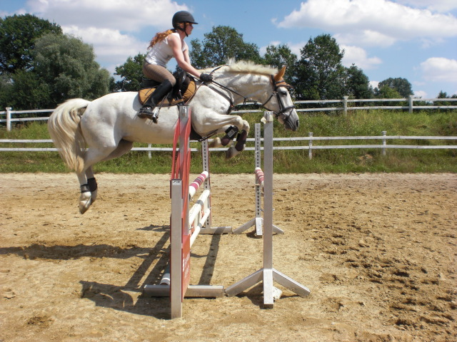

The daughter who won't lift a finger in the house is the same child who cycles madly off in the pouring rain to spend all morning mucking out a stable.
- Watch the film
Horse Jumps - Horse Jumping Gold Medallist David O'Conner gives Tips on Equestrian Jumping Training
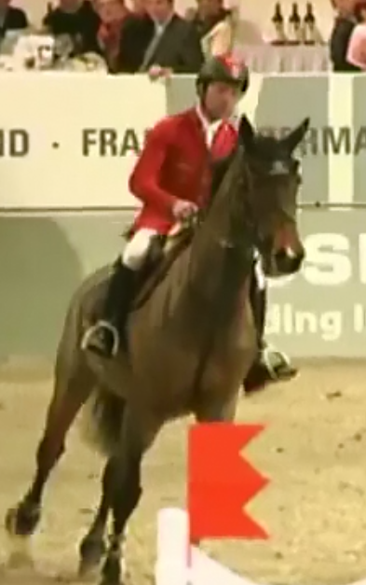
Answer next questions.(Dutch)
- What is the name of the horse?
- What is the distance between the yellow and the blue fence?
- How many strikes is that in a normal competition?
- How many strikes are they experimenting here?
- Which two features are important in this exercise?
- Which two things are to be practised?
- What are the priorities in jumping?
- What went wrong when Laureen tried to do the seven strike version?
- With what object, other than fences, you can do this exercises as well?
- What is always important in David’s opinion?
- How long is the distance between the yellow and the black fence? How many strikes?
- How long is the distance between the black and the blue fence? How many strikes?
- How many strikes took Laureen for the blue fence?

Building Jump Standards

Make jumps at home with a few simple tools.
By Holly Werner
If you board your horse at home or a small local stable, chances are you don’t have a fancy course of jumps on which to practice. The good news is that you can build your own standards with a few common power tools and materials. Inexpensive landscaping poles can be purchased for around $3 each to complete the project. Here’s what you’ll need to get started, followed by step-by-step tips.
TOOLS: Saw or chainsaw and circular saw, drill with ¼-inch bit, ½-inch spade bit and Phillips head screwdriver
MATERIALS: One 8-foot length of treated 4”x4” wood, two 8-foot lengths of treated 1”x4” wood, box of 1 1/2-inch wood screws and pair of jump cups.
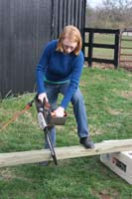 | 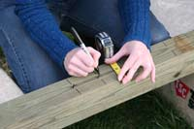
Step 1: Prop the 4”x4” beam up off the ground; sawhorses or bags of shavings/hay bales work equally well. Measure and saw into two four-foot halves. | Step 2: Measure 18” away from the ground end on each of the four-foot pieces just cut. Start marking for jump cup holes in the centre of the beam every three inches until you get to the top.
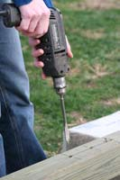 | 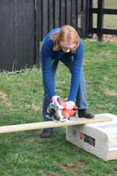
Step 3: Using the ¼-inch drill bit, make a hole at each mark, all the way through the beam. Switch to the ½-inch spade bit and widen each existing hole. | Step 4: Prop a 1”x4” plank off the ground, measuring and marking every 20”. Using the saw or circular saw, cut the board into four “jump feet.” Repeat with other 1”x4” plank.
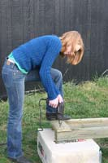 | 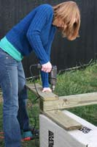
Step 5: Prop up a four-foot 4”x4” beam so one of the feet lines up at a 90-degree angle along the bottom. Use two screws to mount the foot to the base of the beam. | Step 6: Rotate the beam and continue mounting the other three feet in a pinwheel pattern, using two screws for each one.
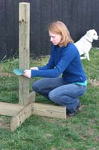
Step 7: Set up your new standard to make sure it’s sturdy, then try mounting a jump cup and pin to check the fit through the holes. | Now you’re ready to tack up and try your new jump!
Answer next questions.(Dutch)
- What can be used as bars for the home made fence?
  - Standards
  - Landscaping poles
  - wood
  - planks
- What tools do you need?
  - Saw, drill, spade bit and screwdriver
  - Wood screws, wood and box
  - Jump cups
  - Treated wood
- To “prop the beam” means?
  - Putting the beam into the standards
  - Measure the beam into two halves
  - Mark the jump cup holes in the centre of the beam
  - Support the beam
- What is the spade bit used for?:
  - To make holes at each mark on the beam
  - To cut the board into “jump feet”
  - To widen the holes in the beam
  - To switch to the ½ -inch spade bit
- What is a pinwheel pattern?
  - 90-degree angle
  - Like the whips of a mill
  - Sturdy pattern
  - Rotation of the beam
- Writing
Write a small story about the adventures you experienced with your horse.
First read this example.
Ok, so at my house we have a stable and my family owns that stable. So Kids take lessons there and that kind of stuff. So I have my own horse there that only I’m supposed to ride, he isn't one of the lesson horses. Him and me have a REALLY good bond. When someone other than me gets on him he rears bucks and doesn't listen at all. But when I ride him he does everything I ask him to do and never rears. So this girl about my age takes lesson's here too. So one day she walked up to me and told me that she wanted to ride my horse in a lesson, she didn't ask she just said: I want to ride Star (my horse) in tomorrow's lesson, and my mom said she's going to make sure I will. And just walked away. So the next day her mom talked to my mom and my mom said no because he's my horse and she doesn't want the girl to get hurt because you ride him a specific way. So she rode a different horse that day. But the next day before I got outside to get Star. She had taken him out of his stall and was already riding him. I nicely told her to give me my horse. And she said: whatever, you don't even ride him the right way. And Galloped into the field and kept riding him. I told my mom that night and she said she would talk to her. So she did but the girl keeps taking Star out and riding him after lessons.

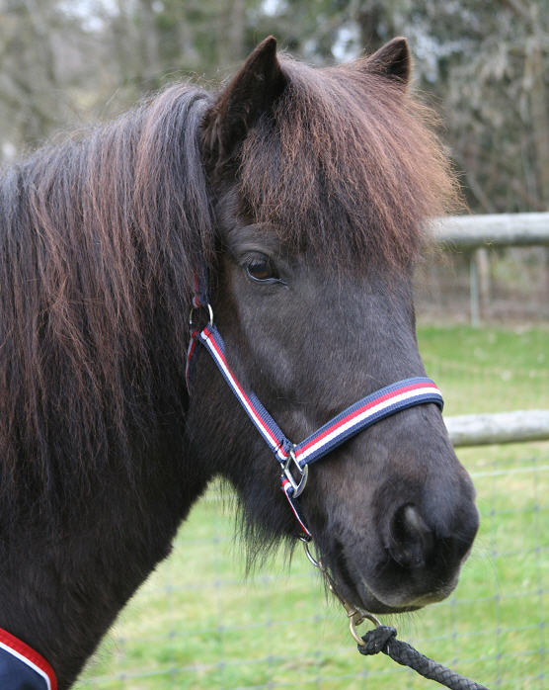

- Telling the story
When you are finished tell your story to 4 or 5 students. Ask them to make notes .

