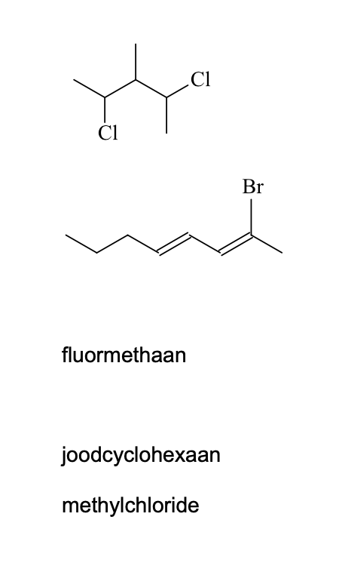

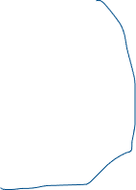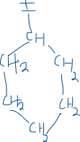

2,4-dichloor-3 -methylpentaan



2-broomocta-2,4-dieen



CH3-F



CH3-Cl

