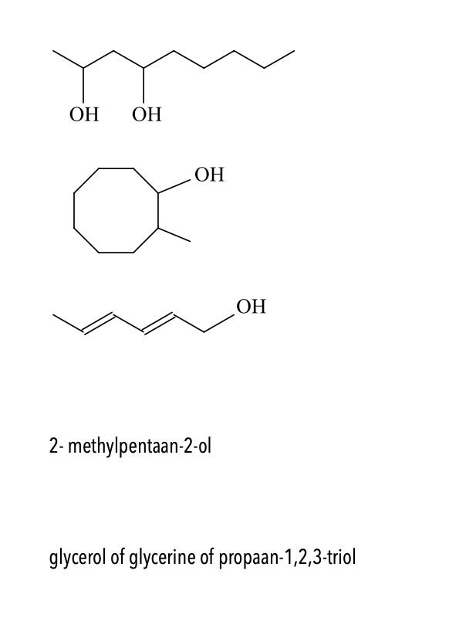



8-methylcycloöctanol en oef 1-:nonaan-2,4-diol



hexa-2,4-diënol of hexa-2,4-dieen-1-ol



CH3-C-CH2-CH2-CH3

