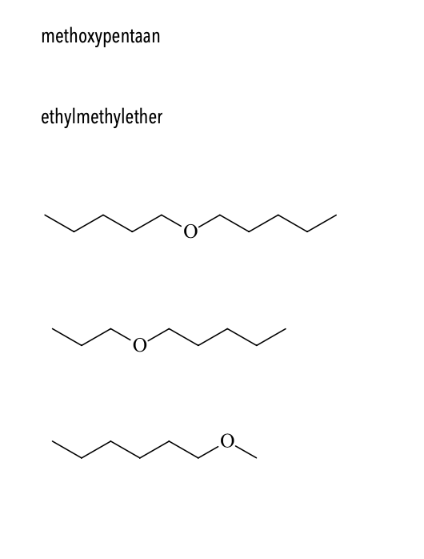



dipentylether of pentoxypentaan

propoxypentaan pf pentylpropylether

methoxyhexaan of hexylmethylether