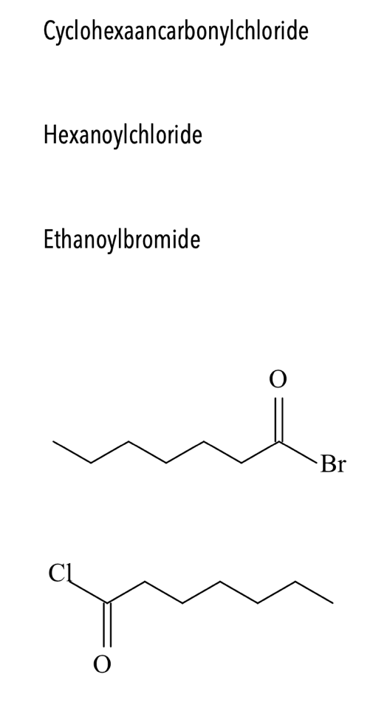



heptanoylbromiode

heptanoylchloride