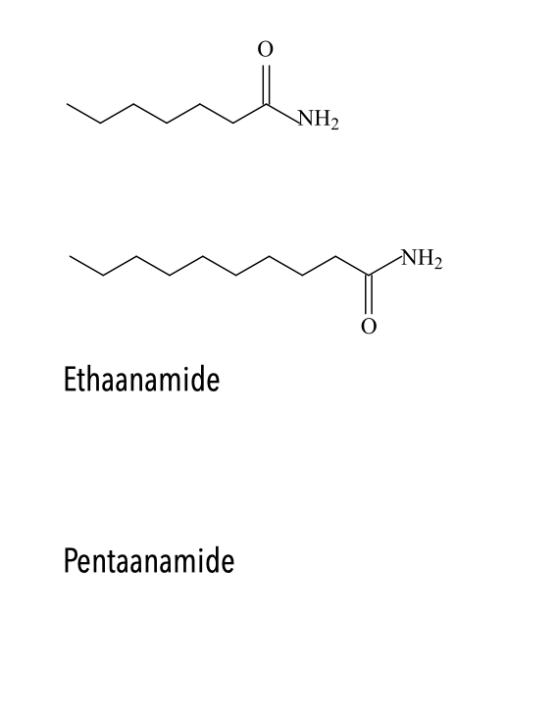

Oplossingen

heptaanamide

decaanamide

CH3-CO-NH2

CH3-(CH2)3- CO-NH2