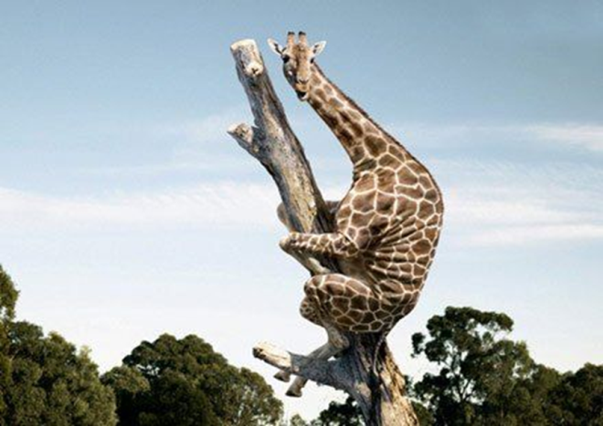

**Bijvoeglijk naamwoord**

Timmy is a fearful giraffe

**Bijwoord**

He holds on to the tree fearfully

**Description: Adverb and Adjective**

Beschrijving: Bijwoord en Bijvoeglijk naamwoord

|  |  |  |  |  |
| --- | --- | --- | --- | --- |
|  | **When**  ***Zegt iets over*** | **Rule** | **Indicator** | **Uitzondering:**  **Goed** |
| Bijvoeglijk naamwoord |  |  |  | Good |
| Bijwoord |  |  |  | Well |

Zelfstandig naamwoord =

1. **Circle the correct word.**
2. She sang beautiful/ beautifully.
3. I asked him polite/ politely.
4. He is a careful/ carefully man.
5. These nice/ nicely girls shared their food with that guy.
6. You have to come home immediate/ immediately.
7. **Look at the first word at the start of each sentence. Fill in the correct form of the word in the gap of both sentences.**

**1.** Careful Timmy is a _______________________ giraffe.

He climbed up the ladder _______________________ .

**2.** Angry The dog is  _______________________ .

It barks _______________________ .

**3.** Excellent He acted  _______________________ .

He's an  _______________________ actor.

**4.** Easy They learn English  _______________________ .

They think English is an  _______________________  language.

**5.** Good Laura is a ________________ singer.

She sings  ________________.

1. **Look at the first word at the start of each sentence. Fill in the correct form of the word in the gap.**

**1.** Beautiful She is a _______________________ girl.

**2.** Fantastic We look _______________________ .

**3.** Ridiculous She talks _______________________ .

**4.** Soft Her voice sounds _______________________ .

**5.** Wonderful David cooks _______________________ .

**6.** Good This is a _______________________ movie.

**7.** Fast The Fast and the Furious is about _______________________ cars.

**8.** Good I can speak English very _______________________ .

**9.** Fantastic She dresses _______________________ .

**10.** Happy The children play _______________________ .