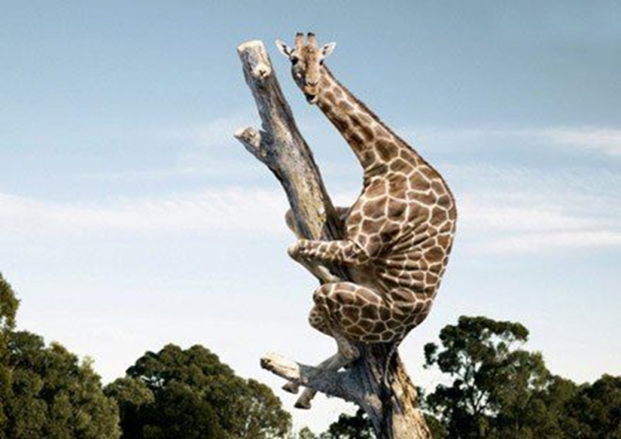

Bijvoeglijk naamwoord
Timmy is a fearful giraffe

Bijwoord
He holds on to the tree fearfully

Description: Adverb and Adjective

Beschrijving: Bijwoord en Bijvoeglijk naamwoord

 | When  Zegt iets over | Rule | Indicator | Uitzondering:  Goed
Bijvoeglijk naamwoord |  |  |  | Good
Bijwoord |  |  |  | Well

Zelfstandig naamwoord =

- Circle the correct word.
- She sang beautiful/ beautifully.
- I asked him polite/ politely.
- He is a careful/ carefully man.
- These nice/ nicely girls shared their food with that guy.
- You have to come home immediate/ immediately.
- Look at the first word at the start of each sentence. Fill in the correct form of the word in the gap of both sentences.
1. Careful Timmy is a _______________________ giraffe.
He climbed up the ladder _______________________ .
2. Angry The dog is _______________________ .
It barks _______________________ .
3. Excellent He acted _______________________ .
He's an _______________________ actor.
4. Easy They learn English _______________________ .
They think English is an _______________________ language.
5. Good Laura is a ________________ singer.
She sings ________________.

- Look at the first word at the start of each sentence. Fill in the correct form of the word in the gap.
1. Beautiful She is a _______________________ girl.
2. Fantastic We look _______________________ .
3. Ridiculous She talks _______________________ .
4. Soft Her voice sounds _______________________ .
5. Wonderful David cooks _______________________ .
6. Good This is a _______________________ movie.
7. Fast The Fast and the Furious is about _______________________ cars.
8. Good I can speak English very _______________________ .
9. Fantastic She dresses _______________________ .
10. Happy The children play _______________________ .

