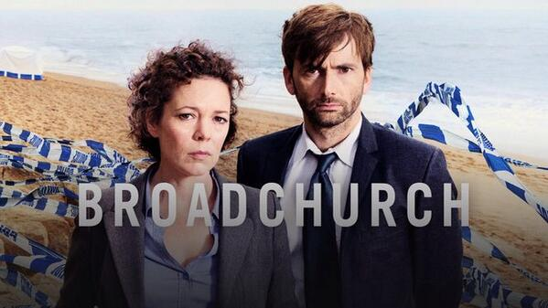

‘Broadchurch’ Season 1 episode 1
- What reason does the family’s father (Mark) give for the fact all the clocks have stopped ticking overnight?
____________________________________________________________________________________________________________________________________________________________________________________________________________
- What reason does workmate Nigel give for arriving late with the work van?
____________________________________________________________________________________________________________________________________________________________________________________________________________
- Why does the name ‘inspector Alec Hardy’ sound familiar to sergeant Ellie?
____________________________________________________________________________________________________________________________________________________________________________________________________________
- When does mum Beth first realise she doesn’t know where her son Danny is?
____________________________________________________________________________________________________________________________________________________________________________________________________________
- When does mum Beth realise something’s seriously wrong with Danny?
____________________________________________________________________________________________________________________________________________________________________________________________________________
- What is sergeant Ellie’s relationship to the boy found on the beach?
____________________________________________________________________________________________________________________________________________________________________________________________________________
- Does the forensic expert expect Danny to have fallen off the cliff? Why or why not?
____________________________________________________________________________________________________________________________________________________________________________________________________________
- Why does Danny normally get up before the rest of the family does?
____________________________________________________________________________________________________________________________________________________________________________________________________________
- Why would inspector Alec Hardy say ‘all of this remains confidential, no gossip’ to the detectives?
____________________________________________________________________________________________________________________________________________________________________________________________________________
- How did Danny die according to the coroner (lijkschouwer)?
____________________________________________________________________________________________________________________________________________________________________________________________________________
- Why is Chloe’s boyfriend afraid the police might find out about them being in a relationship?
____________________________________________________________________________________________________________________________________________________________________________________________________________
- Why does Chloe go to the beach where Danny’s body is found?
____________________________________________________________________________________________________________________________________________________________________________________________________________
- Does the family know Danny Latimer’s name has been released to the press?
____________________________________________________________________________________________________________________________________________________________________________________________________________
- Why are the two reporters from the newspaper ‘The Echo’ waiting for inspector Hardy in the bar?
____________________________________________________________________________________________________________________________________________________________________________________________________________
- When sergeant Ellie arrives back home to take a quick shower, does her son Tom already know his friend Danny is dead?
____________________________________________________________________________________________________________________________________________________________________________________________________________
- What does Tom do after he hears his best friend Danny died?
____________________________________________________________________________________________________________________________________________________________________________________________________________
- What does the CCTV-footage (camerabeelden) proof about the disappearance of Danny?
____________________________________________________________________________________________________________________________________________________________________________________________________________

