

kg

1 kilogram = 1000 gram

*1 ton = 1000 kg*



hg

1 hectogram = 100 gram

*1 ons = 100 gram*



dag

1 decagram = 10 gram



g

1 gram

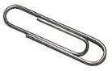

dg

10 decigram = 1 gram

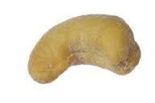

cg

100 centigram = 1 gram



mg

1000 milligram = 1 gram