Egg Osmometers
Nancy Iversen, Cooperstown, New York

Aims: to examine the dynamics of concentration gradients and diffusion with a simple egg osmometer.

Materials:
- fresh egg
- drinking straws
- hot glue gun with glue
- distilled water
- 50 ml beaker

Procedure:
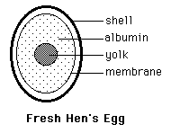
- Prepare a fresh hen's egg by gently tapping on the shell at one end with a blunt instrument to crack the shell without damaging the underlying shell membranes.
- Remove the shell fragments, but do not remove or tear the membrane. Allow the contents of the egg to remain undisturbed.
- At the other end of the egg, remove a small portion of the shell and puncture a tiny hole in the membrane, as well. Allow the contents of the egg to stay inside the egg!
- Insert a plastic drinking straw into the top of the egg through the hole in the membrane.
- Seal the straw into position with a hot glue gun, being certain the seal does not leak.
- Set the membrane end of the egg in a 50 ml beaker of distilled water. Add more water through the beaker's spout from time to time as needed. Be sure the water covers the membrane at all times.
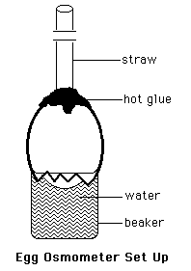
Observations:
- Check your osmometer frequently over the next twenty-four hour period. Each time you check it, record the time and measure the height of any fluid in the straw. Add more water as needed.
- Make a graph of fluid rise over time.

Discussion:
- Explain your observations in detail in terms of concentration gradient, diffusion, osmosis, osmotic pressure, passive transport, and active transport.
- How might we be able to use our simple egg osmometers to estimate the amount of pressure exerted on the egg membrane at any one time during the twenty-four hour observation period?

Bron: http://www.accessexcellence.org/AE/ATG/data/released/0519-NancyIversen/activity.php

