Musical Peas

Concept: Osmosis-the movement of water along a gradient from high concentration to low concentration.
This demonstration shows an example of osmosis. Most students have seen demonstrations of carnations or celery in glasses of colored water where the tips of the petals or leaves turn to the color of the water. With this demonstration, students are able to see a more accurate depiction of omosis.

Materials Needed:
- aluminum pan
- dried peas (split or whole)
- a glass with a stem
- water at room temperature
Step One: place the glass in the aluminum pan; fill glass to rim with dried peas
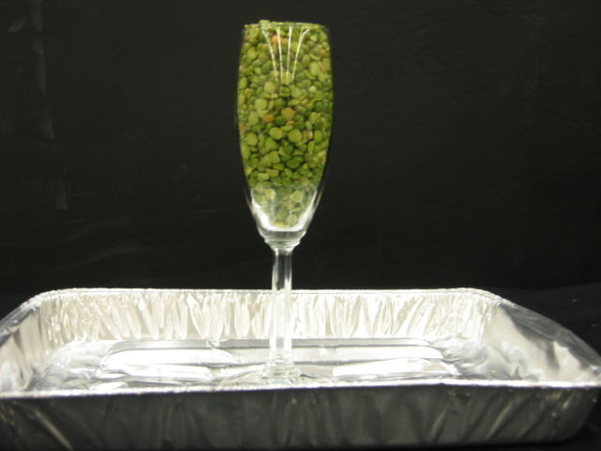

Step Two: Add water until it reaches the rim of the glass
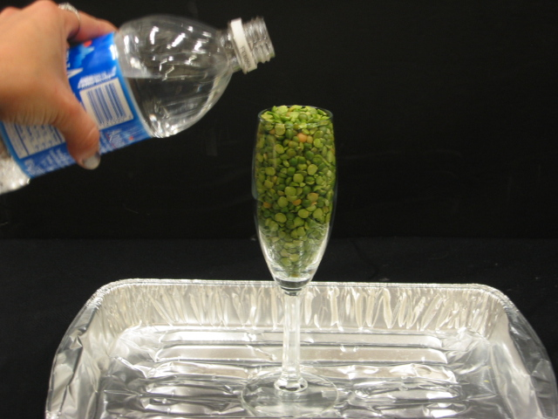

Step Three: Wait about an hour then peas will begin their musical piece!
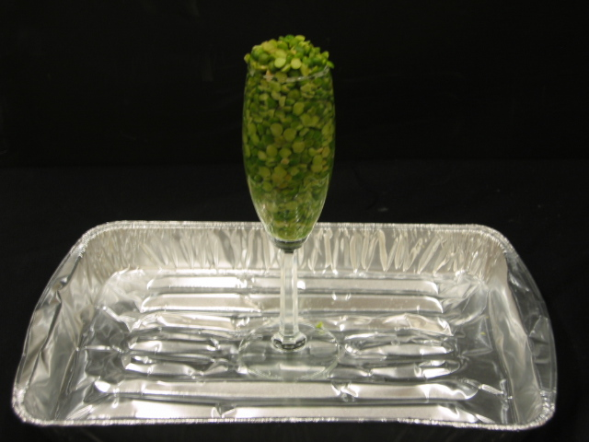
First, you will see the peas expand over the rim......

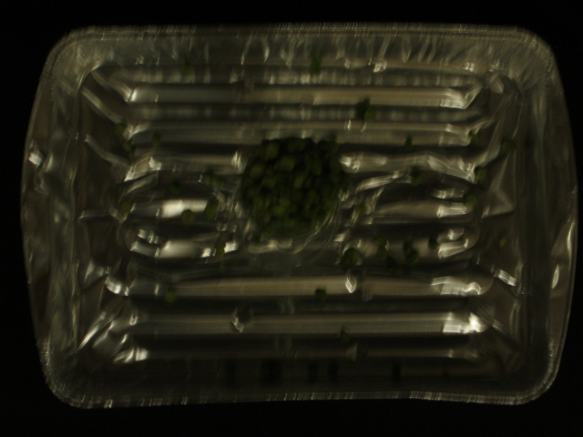
Next, you will hear them ding on the alumninum pan!!

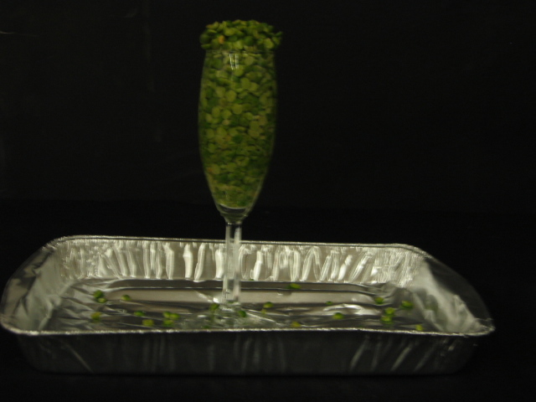

Questions to think about
1. Describe osmosis in terms of what happened in this demonstration.
2. What factors may have affected the rate of osmosis?
3. Use the scientific process to develop a hypothesis, make a prediction and test for each of the following variables: if we used hot water; if we used ice water; if we used (a substance of your choice)

Bron: http://web.archive.org/web/20030717155233/http:/purcell.phy.nau.edu/courses/02/spring/sci420/stuproj/webpages/morford_dawn/index.html

