Baby Faces, Product Design and Evolutionary Theory

Cars that share the general traits of a baby’s face trigger the ‘Isn’t it cute’ response in consumers.
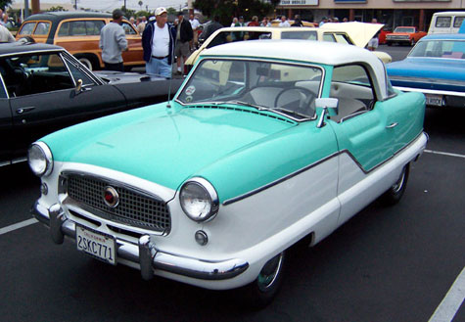

Of course, being cute isn't the only key to sales success. (Photo by Matthew Brown)

October 22, 2010• By Sally Augustin • No Comments and 0 Reactions

Linda Miesler and Helmut Leder decided to put evolutionary theory to the test in the product design world. At the 7th International Design and Emotion Conference in Chicago, Miesler, a doctoral student, presented the lessons that she and Leder, a psychology professor, learned about baby faces and responses to designed objects.
There’s a body of research indicating that humans think human baby faces are cute and respond positively to them — this is where the evolutionary theory comes in. It’s good for us to respond positively to our young. Baby faces share certain attributes — relatively large eyes, and smallish noses and mouths, for example. Humans smile at and have positive emotional reactions to objects they feel are cute.
Another whole set of studies has shown that humans perceive the front end of a car as a human face. The headlights are eyes, the grill a nose, and the air intake a mouth. We infer attributes for the car, such as gender, based on the face that we see.
Miesler and Leder, as detailed in their paper “The Cute Look: Baby-Schema Effects in Product Design,” had people look at images of cars that had been altered so that their “faces” were more baby-like and also the original head-on photos of the same cars. In the modified images, the headlights had been made 20 percent larger, the grill 20 percent smaller and the air intake 20 percent narrower but 20 percent higher — babies lips are not as wide laterally as an adults, but fuller. Some of the cars involved were compact and some were mid-size. Cross-sections of the compact cars were rounder than the larger cars, which also has a potential cuteness ramification — comfortably padded babies rank higher on the cuteness meter than scrawny ones.
The altered images of the cars were seen as cuter than the altered ones, and compact cars were cuter than midsized ones.
Although not everyone wants a cute car, at least some car shoppers do, and designers now have some empirical support for making certain models look at us with baby faces. Not all brands are congruent with cuteness. Somehow, a Hummer with a baby face doesn’t seem like a very good idea — better to apply these findings to cell phones than vehicles designed by the Defense Department.

